1)Setup Minikube in your local machine.

Minikube Setup & Deployment Documentation (Windows)

🔹 1. Objective
To set up a local Kubernetes cluster using Minikube and deploy a sample application.

🔹 2. Prerequisites
- Windows 10/11
- Virtualization enabled
- Docker Desktop installed and running
- Internet connection

Minimum:
- 2 CPU cores
- 2 GB RAM (4 GB recommended)
- Virtualization enabled

Check:
Press Ctrl + Shift + Esc → Task Manager → Performance tab → CPU

Look for:
👉Virtualization: Enabled
✔️ If enabled → good
❌ If disabled → enable in BIOS
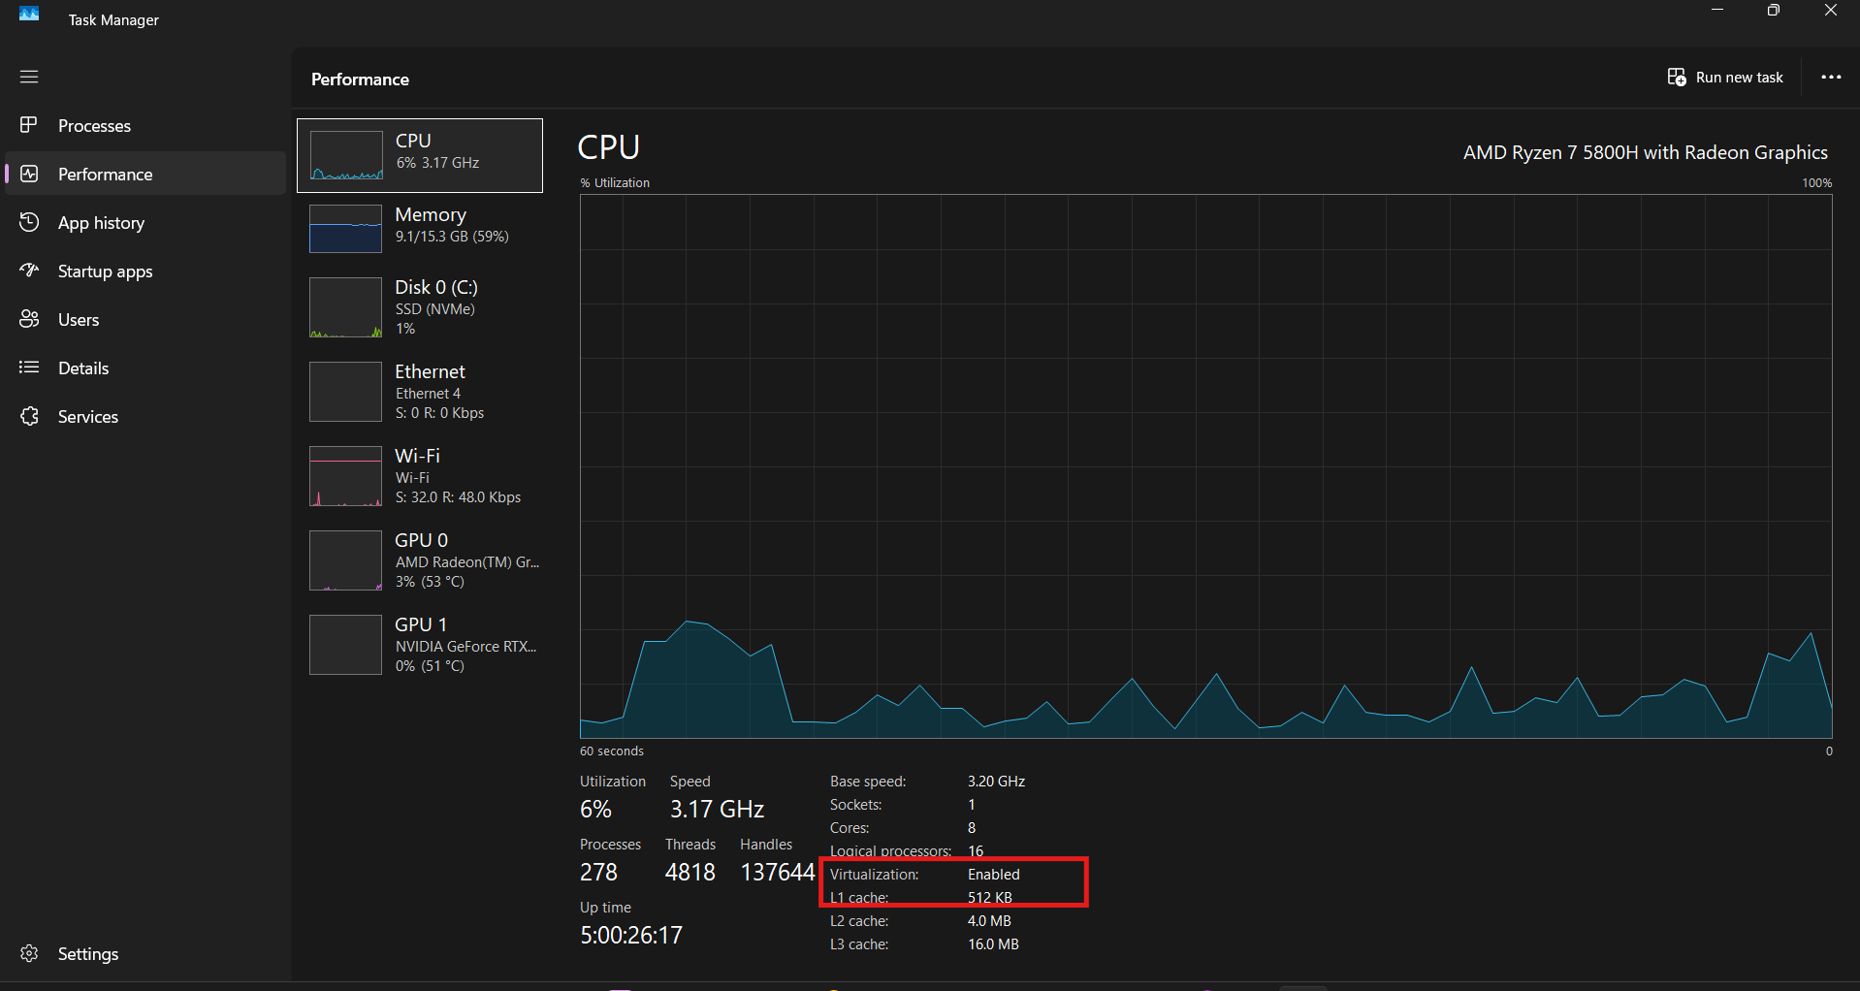

🔹 3. Install Minikube

Step 1: Download Minikube
Powershell
Invoke-WebRequest -OutFile 'C:\minikube\minikube.exe' -Uri 'https://github.com/kubernetes/minikube/releases/latest/download/minikube-windows-amd64.exe'

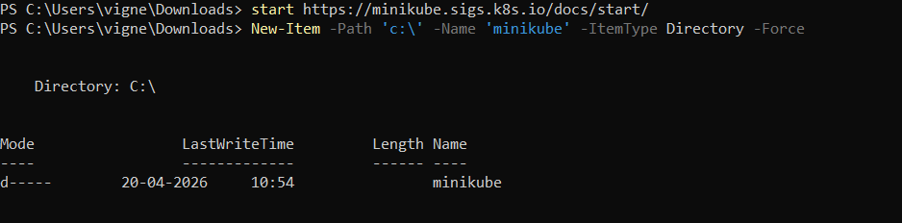

Step 2: Verify Installation
Powershell
C:\minikube\minikube.exe version

Step 3: Add to PATH
Add Minikube to PATH
- Press Windows key
- Search → Environment Variables
- Open → Edit the system environment variables
- Click → Environment Variables
- Under System Variables → select Path
- Click Edit → New
- Add: C:\minikube
- Click OK

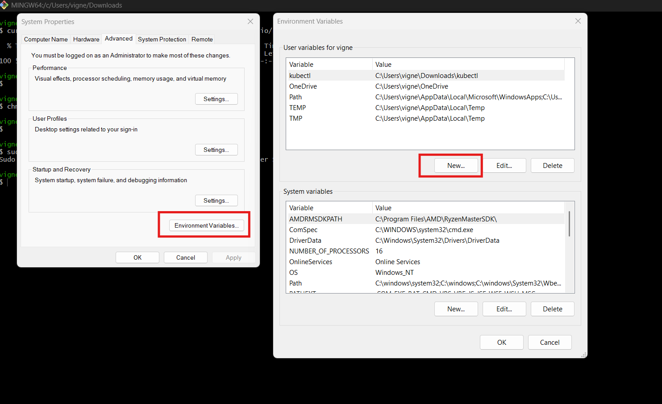
(Or)

Run This In Windows Powershell As Administrator
[Environment]::SetEnvironmentVariable("Path", $env:Path + ";C:\minikube", [EnvironmentVariableTarget]::Machine)
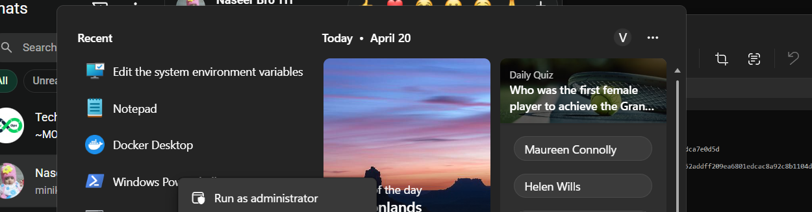
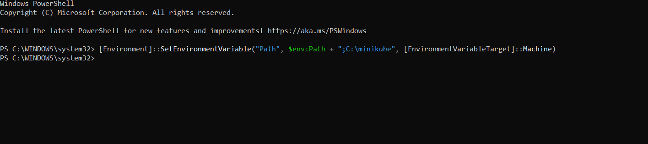

4. Start Minikube Cluster
C:\minikube\minikube.exe start --driver=docker

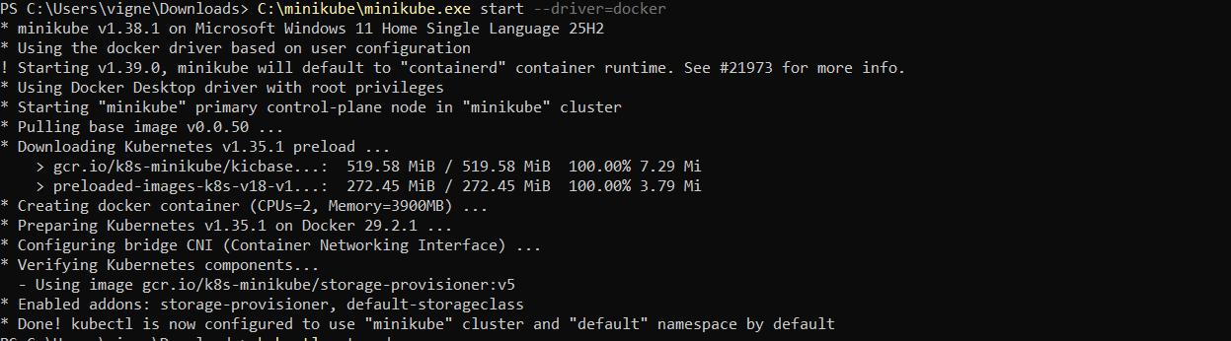
This will:
- Create Kubernetes cluster
- Configure kubectl
- Start control plane

5. Verify Cluster
kubectl get nodes

Expected Output:
minikube Ready

6. Deploy Application
Step 1: Create Deployment
kubectl create deployment hello-minikube --image=kicbase/echo-server:1.0

Step 2: Expose Deployment
kubectl expose deployment hello-minikube --type=NodePort --port=8080

7. Access Application
C:\minikube\minikube.exe service hello-minikube

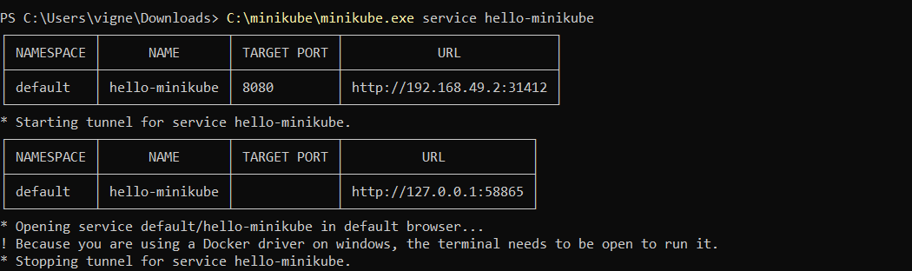

Opens browser with URL like:
http://127.0.0.1:XXXXX
http://127.0.0.1:58865/

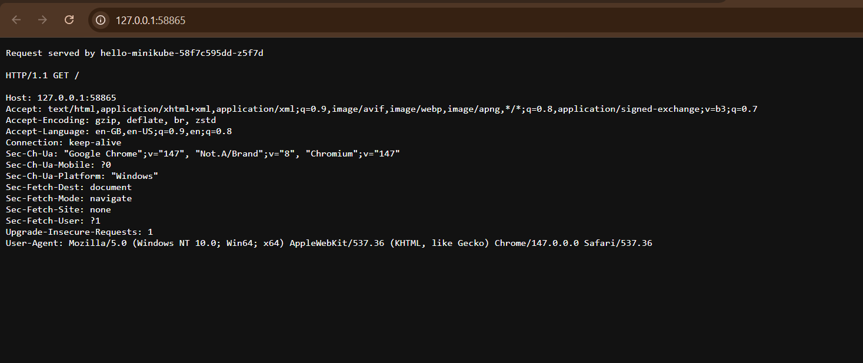
8. Verify Output
Example response:
Request served by hello-minikube-xxxxx
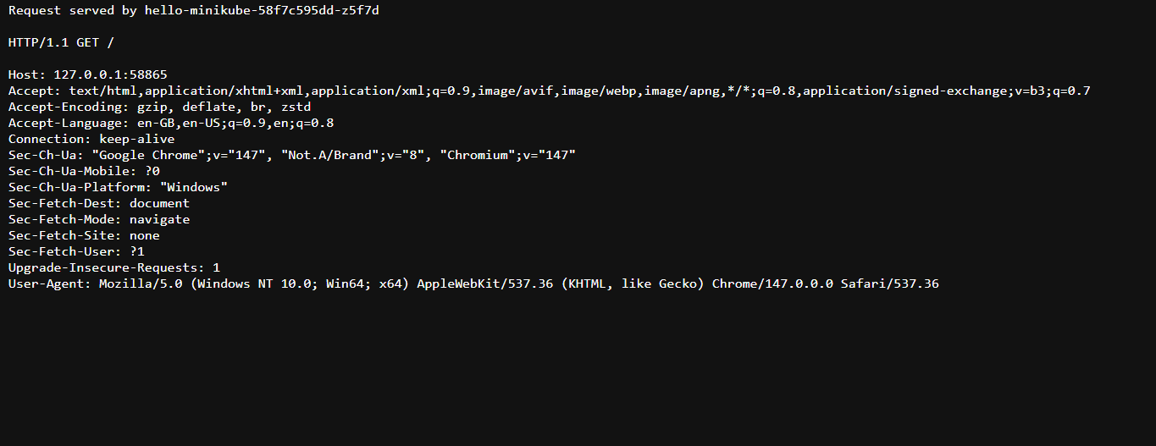
Confirms:
- Pod is running
- Service is working
- Request routing successful
9. Scaling Application
kubectl scale deployment hello-minikube --replicas=3

Check:
kubectl get pods

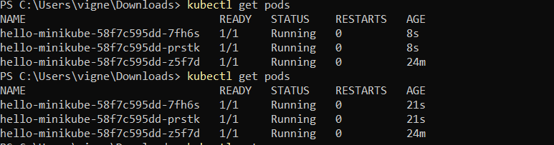
✔ Multiple pods will be created

10. Useful Commands
kubectl get pods
kubectl get svc
kubectl get all
kubectl describe pod <pod-name>

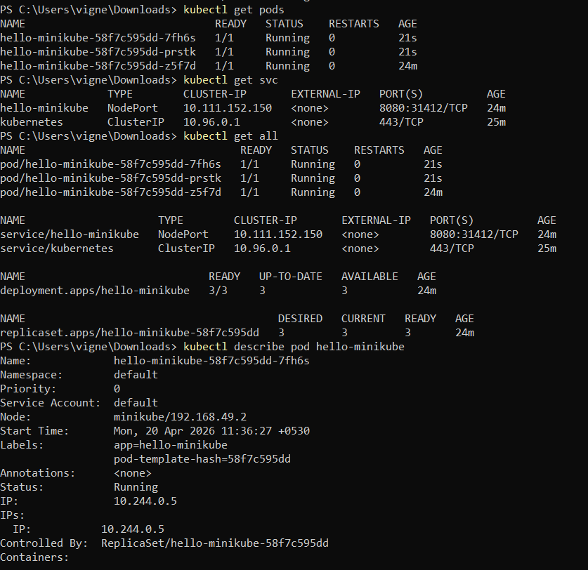
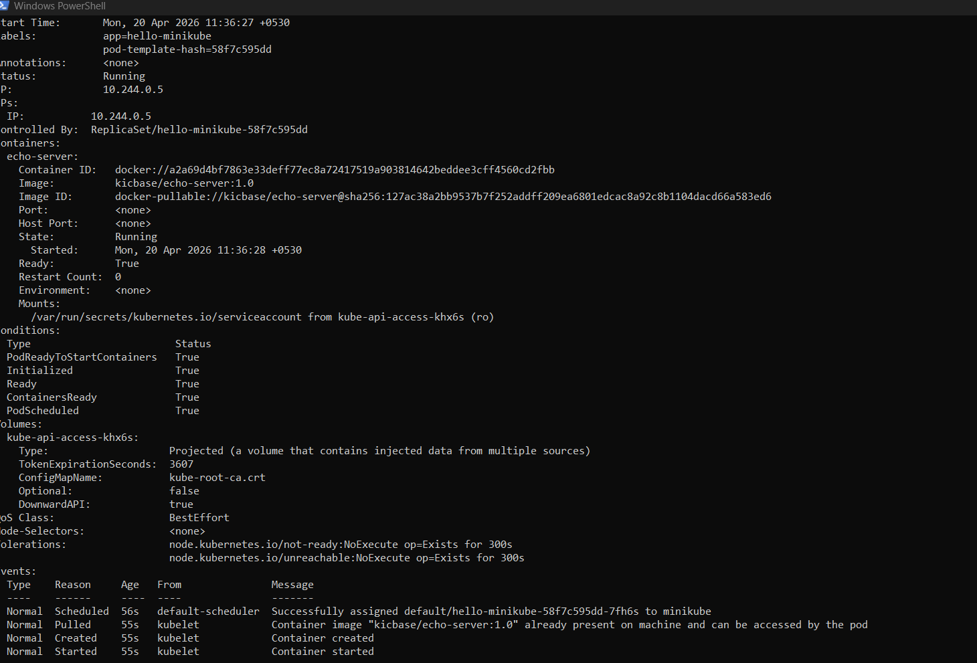

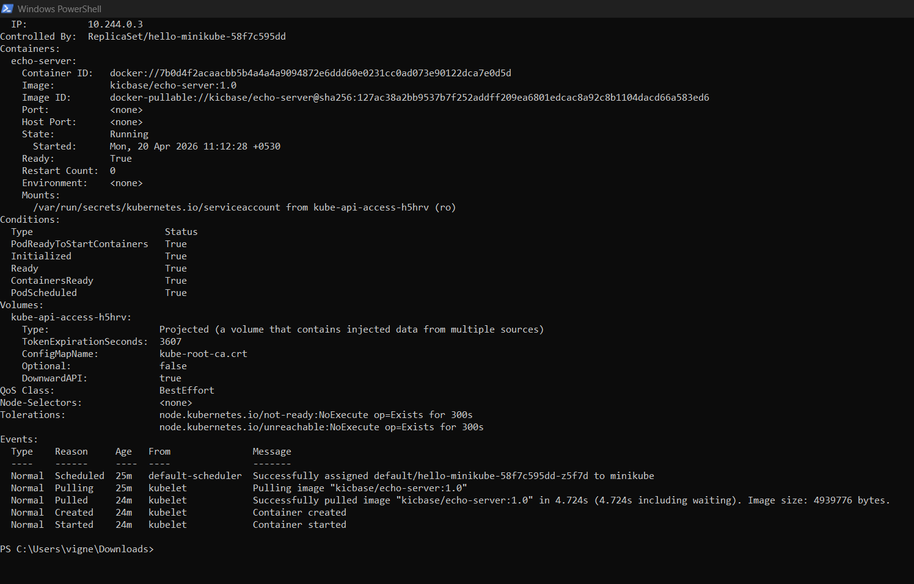

11. Architecture Flow
User → Browser → NodePort Service → Pod → Container → Response

12. Key Concepts
Component | Description
Pod | Smallest unit (container)
Deployment | Manages pods
Service | Exposes application
NodePort | External access
Minikube | Local Kubernetes

Command |  |  |  |  |  |  |  |  | Purpose
minikube start |  |  |  |  |  |  |  |  | Start cluster
minikube stop |  |  |  |  |  |  |  |  | Stop cluster
minikube delete |  |  |  |  |  |  |  |  | Delete cluster
minikube status |  |  |  |  |  |  |  |  | Check status
kubectl get pods |  |  |  |  |  |  |  |  | View pods
To check the minikube use below commands
minikube version
minikube ip
minikube status
minikube ssh
Afrer entering in minikube then logout using exit
Exit
Kubectl get pods
To Check MiniKube On Kubernetes Dashboard
Minikube dashboard

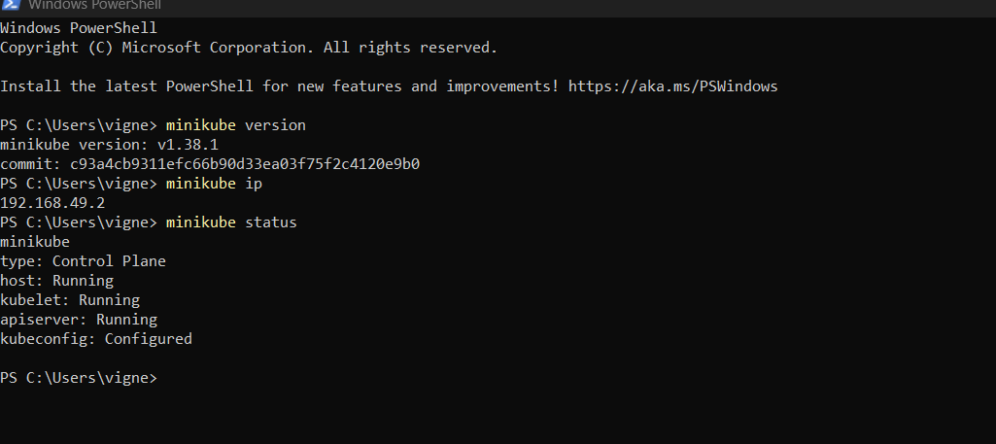
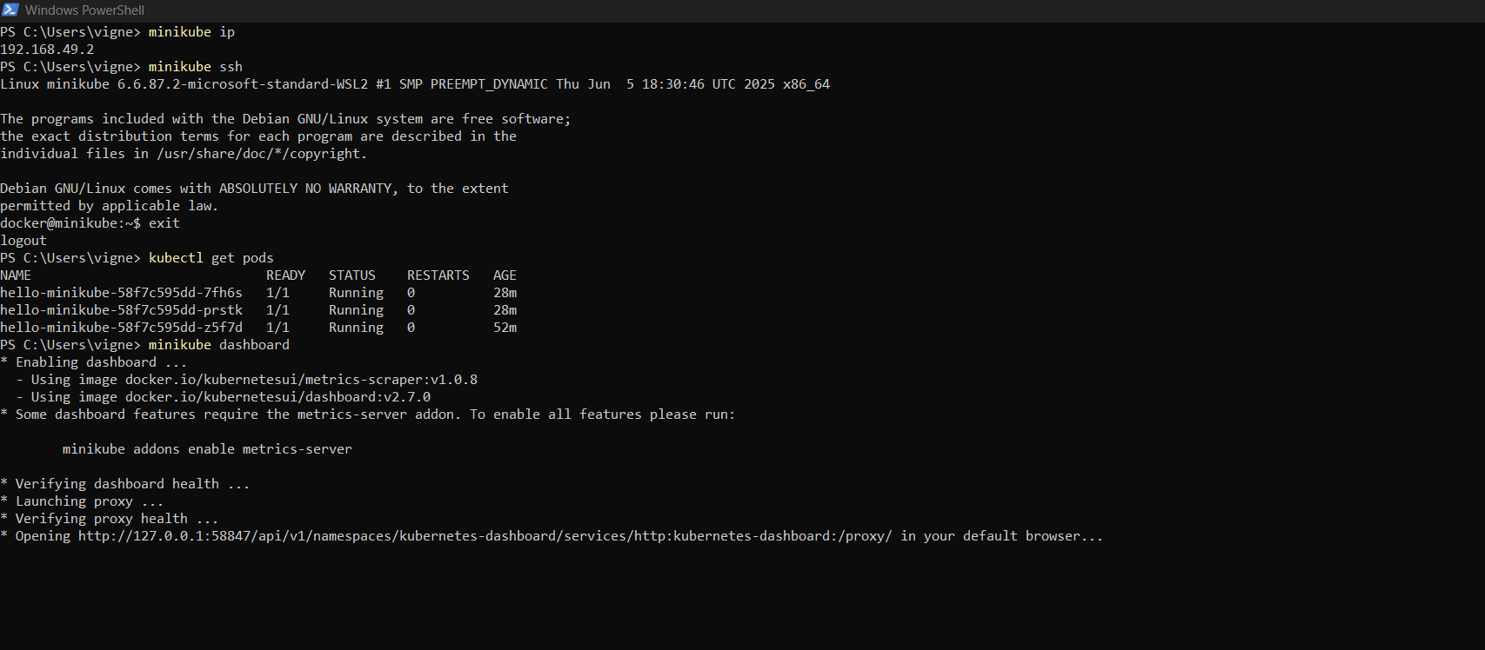
Verify Kubernetes Dashboard
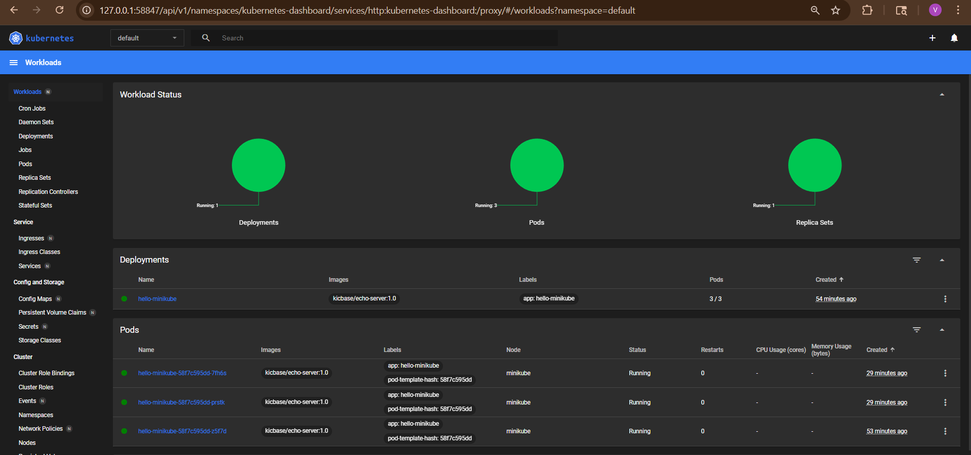
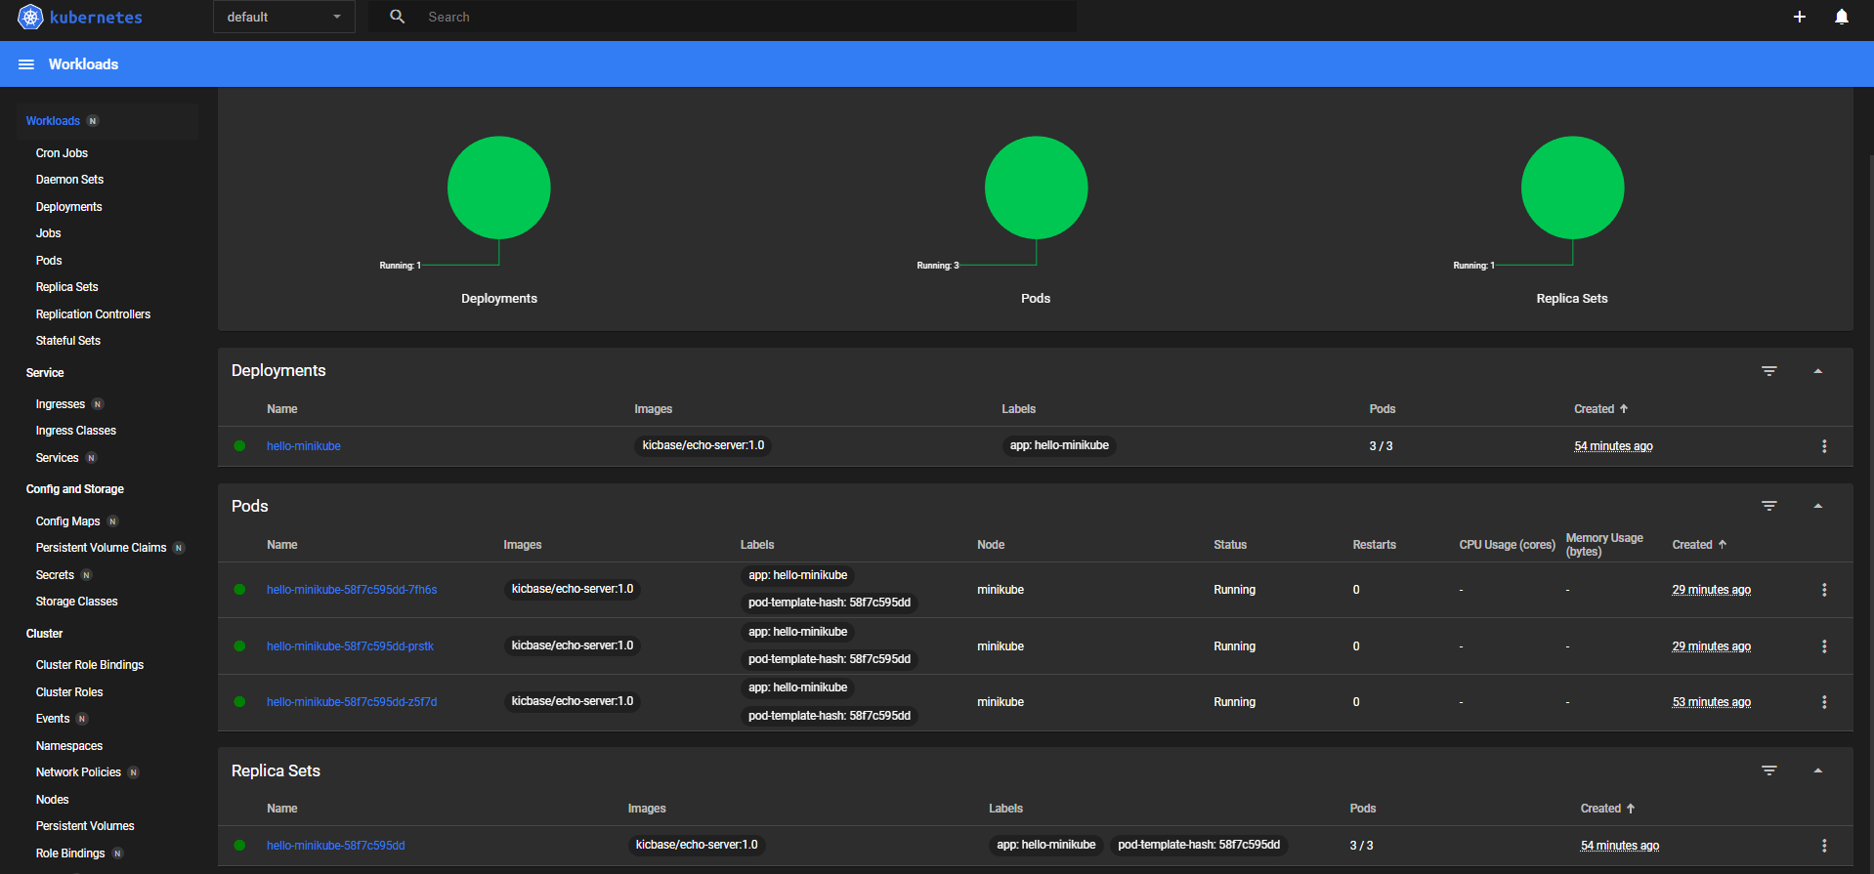

Verify In Docker
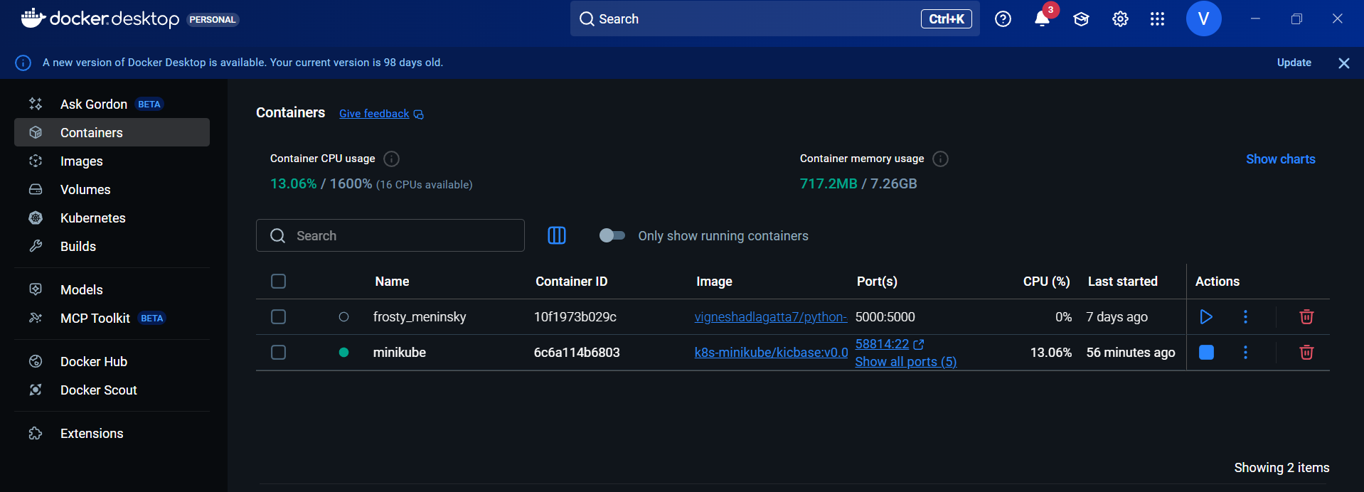
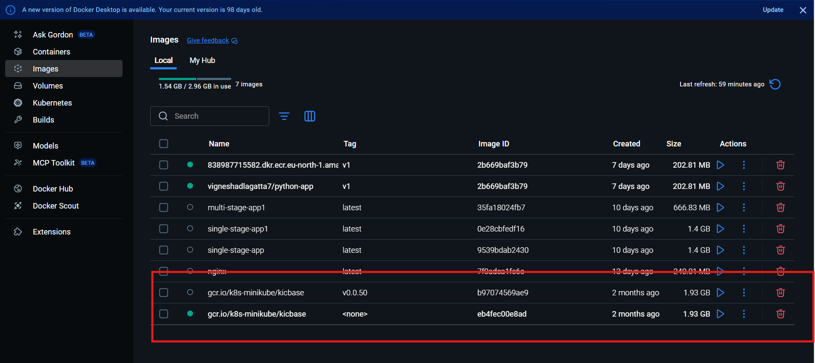

2) Setup k8s master and two worker nodes on ubuntu.

Architecture
- Master Node (Control Plane) → manages cluster
- 2 Worker Nodes → run applications
Prerequisites (ALL 3 Machines)
👉 Minimum:
- Ubuntu 20.04 / 22.04
- 2 CPU, 2GB RAM (Worker), 4GB RAM (Master recommended)
- Root or sudo access
- Unique hostnames
Example:
Master: k8s-master
Worker1: k8s-worker1
Worker2: k8s-worker2
Launch 3 EC2 Instances

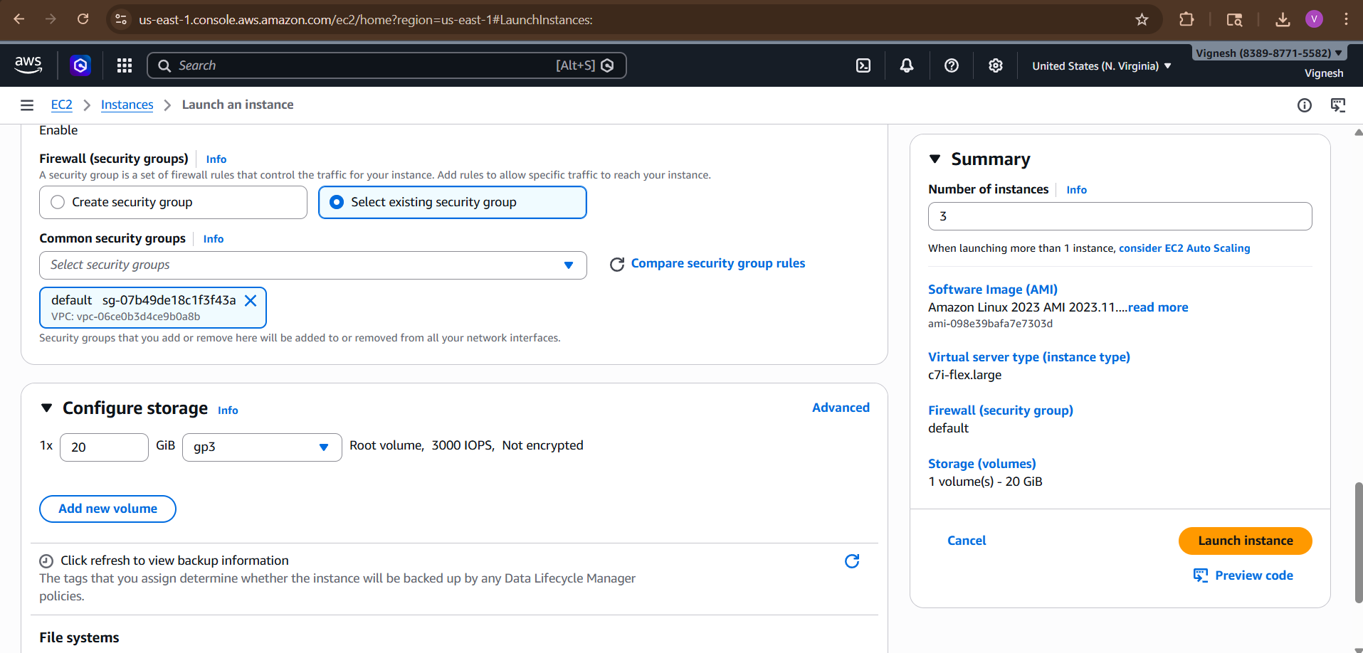

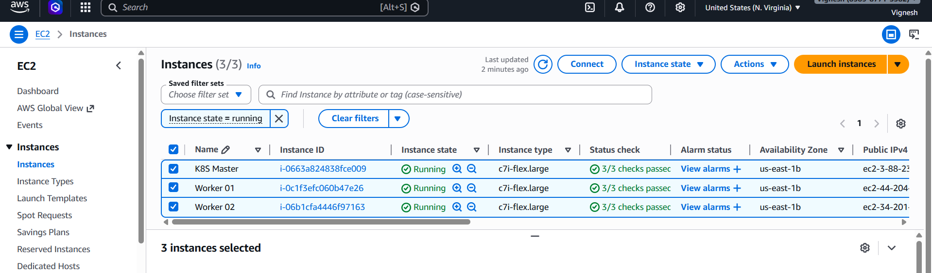

STEP 1: Set Hostnames (ALL NODES)
sudo hostnamectl set-hostname k8s-master # on master

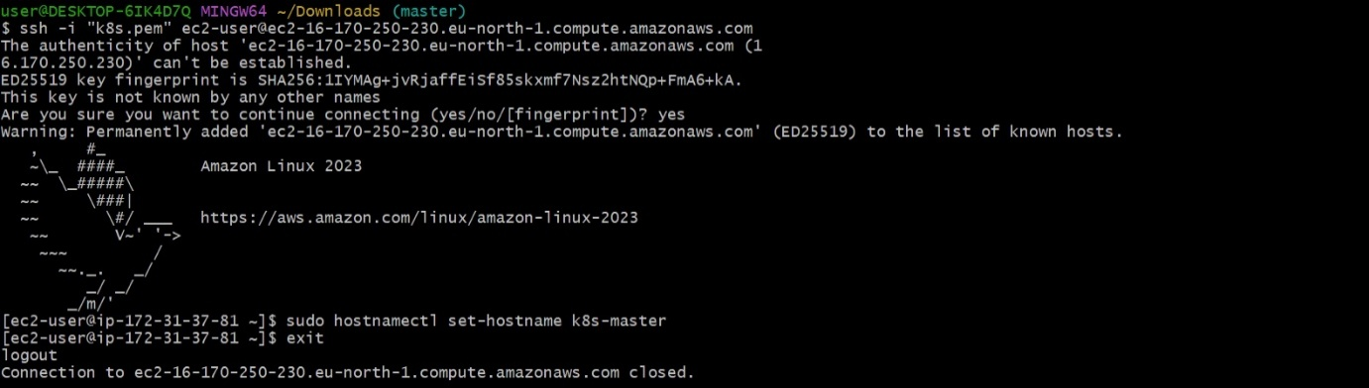
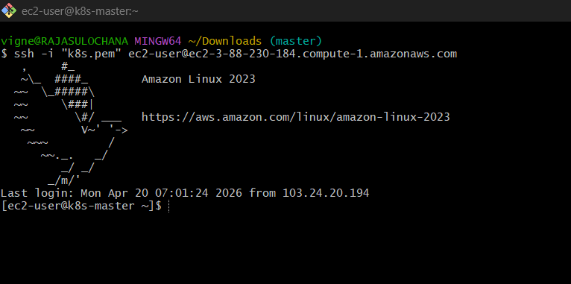

sudo hostnamectl set-hostname k8s-worker1 # worker1

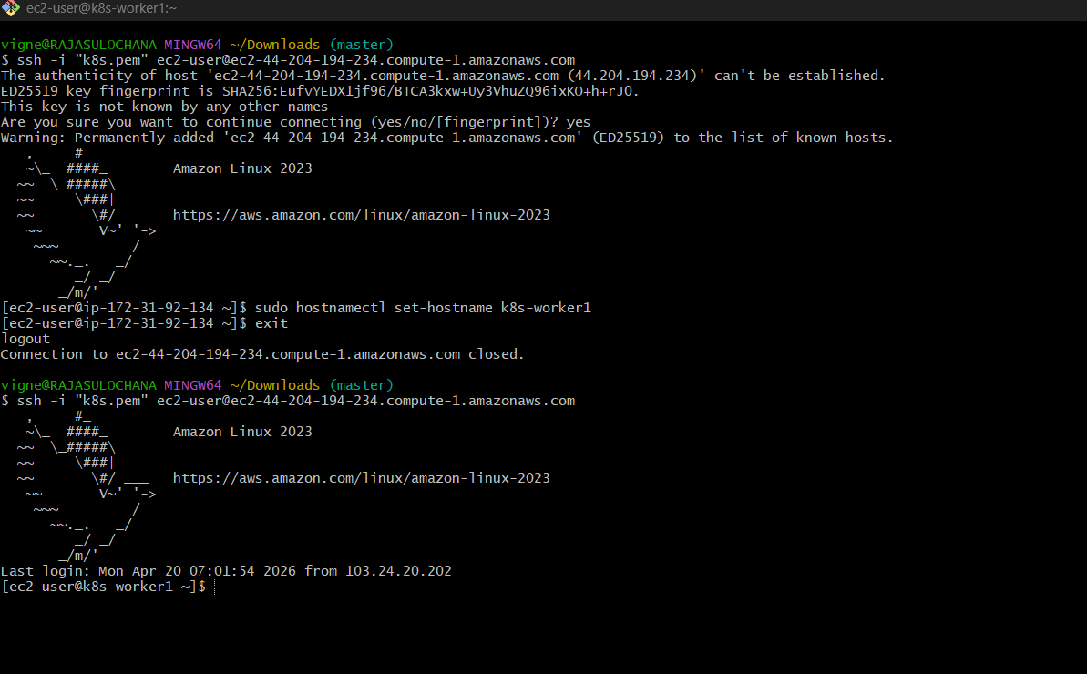

sudo hostnamectl set-hostname k8s-worker2 # worker2

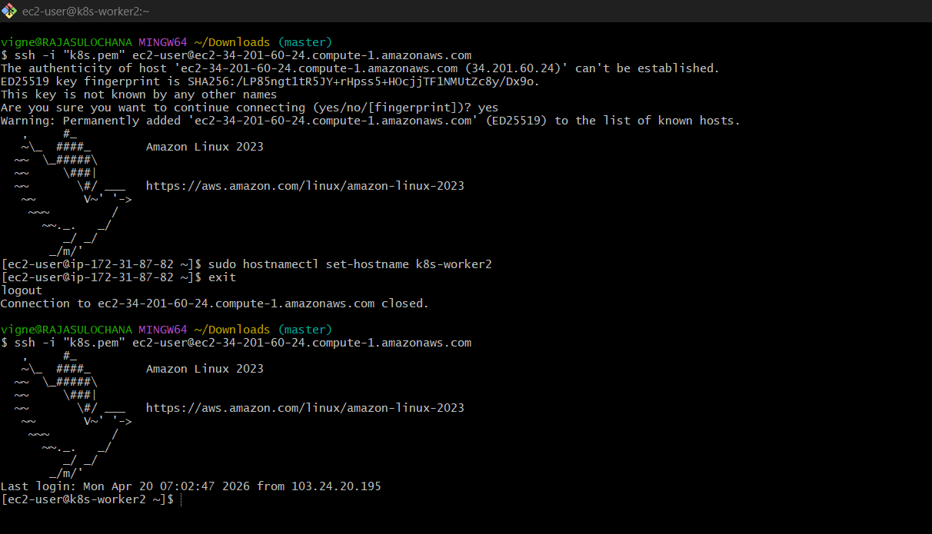
STEP 2: Update /etc/hosts (ALL NODES)
Edit:
sudo nano /etc/hosts
Add:
<MASTER-IP> k8s-master

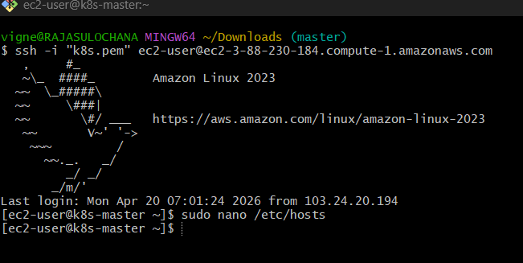
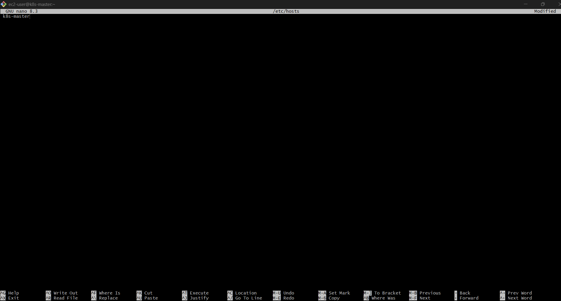

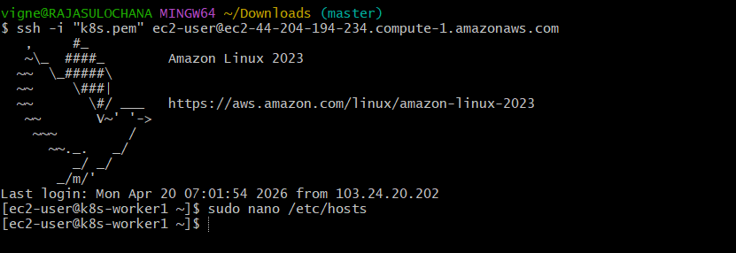

Edit:
sudo nano /etc/hosts
Add:
<WORKER1-IP> k8s-worker1

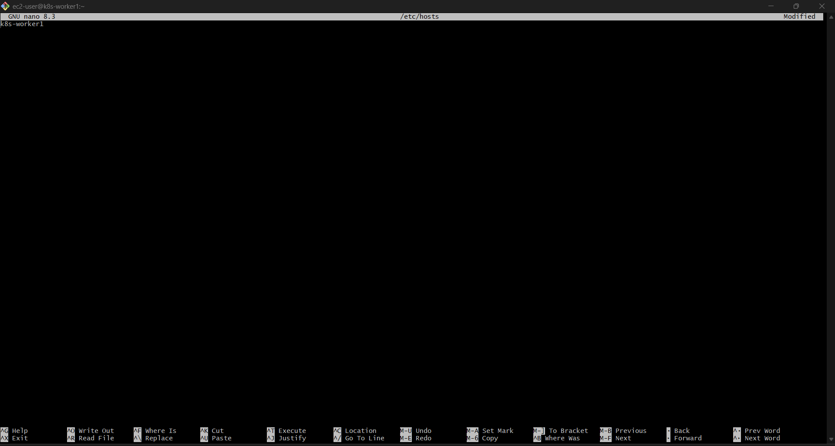

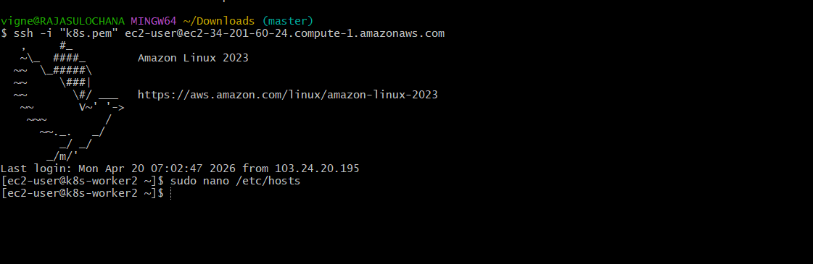

Edit:
sudo nano /etc/hosts
Add:
<WORKER1-IP> k8s-worker2

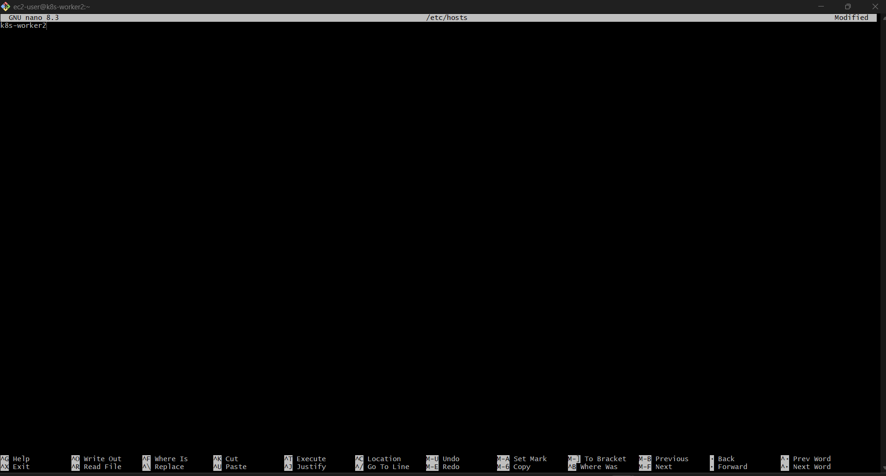

STEP 3: Disable Swap (ALL NODES)
sudo swapoff -a
sudo sed -i '/ swap / s/^/#/' /etc/fstab
👉 Kubernetes won’t work if swap is ON.
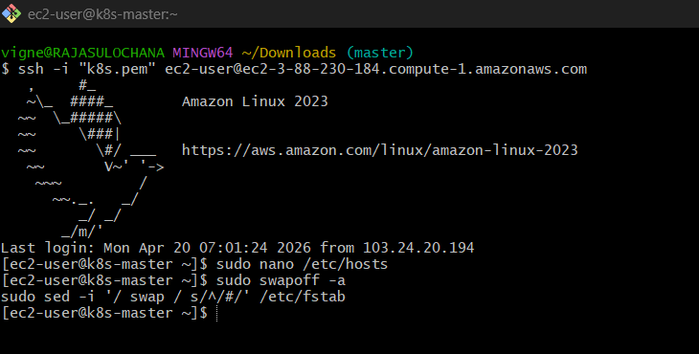

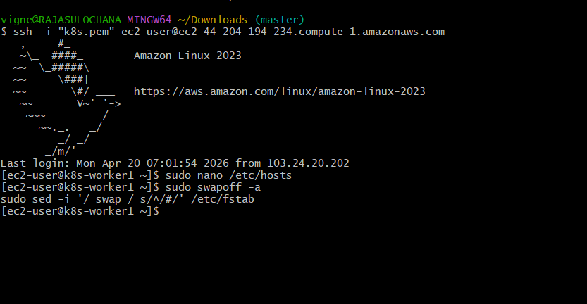
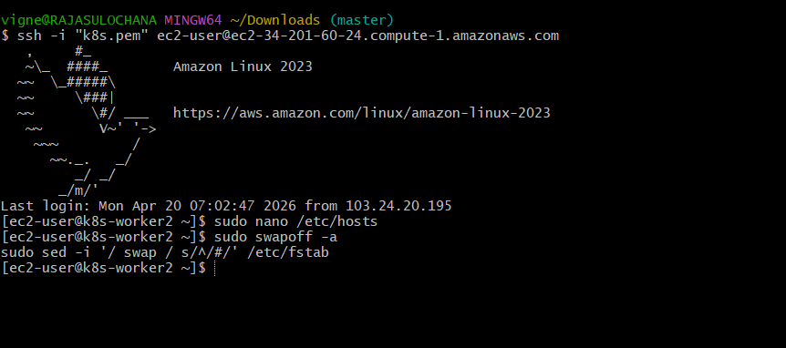
STEP 4: Enable Kernel Modules (ALL NODES)
cat <<EOF | sudo tee /etc/modules-load.d/k8s.conf
overlay
br_netfilter
EOF
sudo modprobe overlay
sudo modprobe br_netfilter
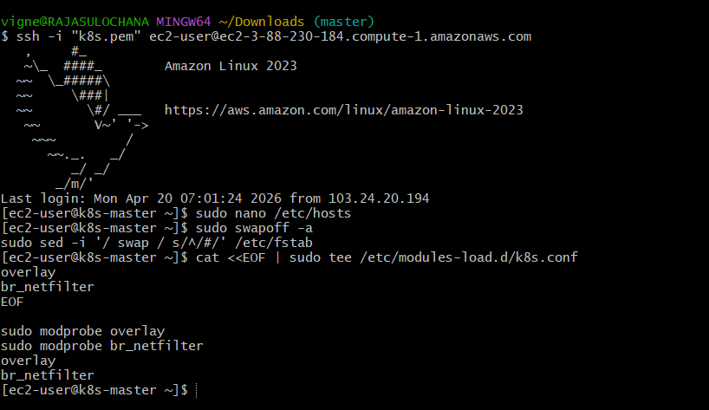
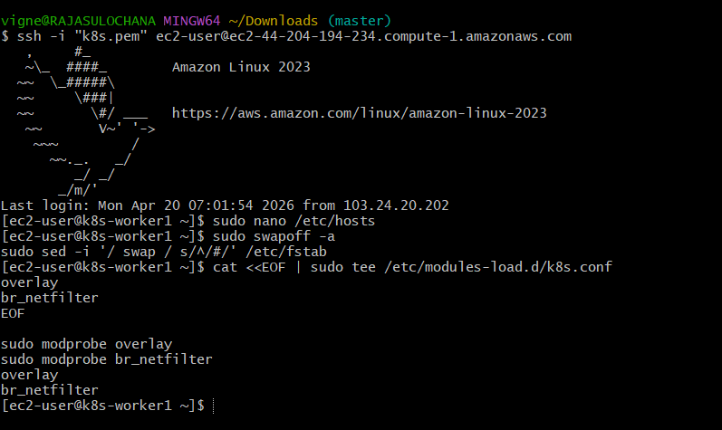
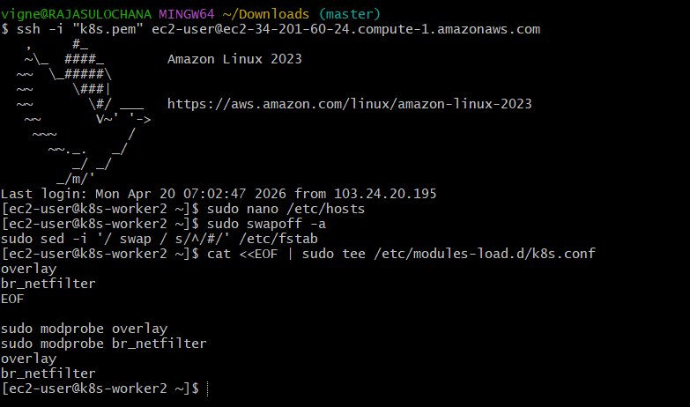

STEP 5: Sysctl Settings (ALL NODES)

cat <<EOF | sudo tee /etc/sysctl.d/k8s.conf
net.bridge.bridge-nf-call-iptables = 1
net.bridge.bridge-nf-call-ip6tables = 1
net.ipv4.ip_forward = 1
EOF
sudo sysctl –system
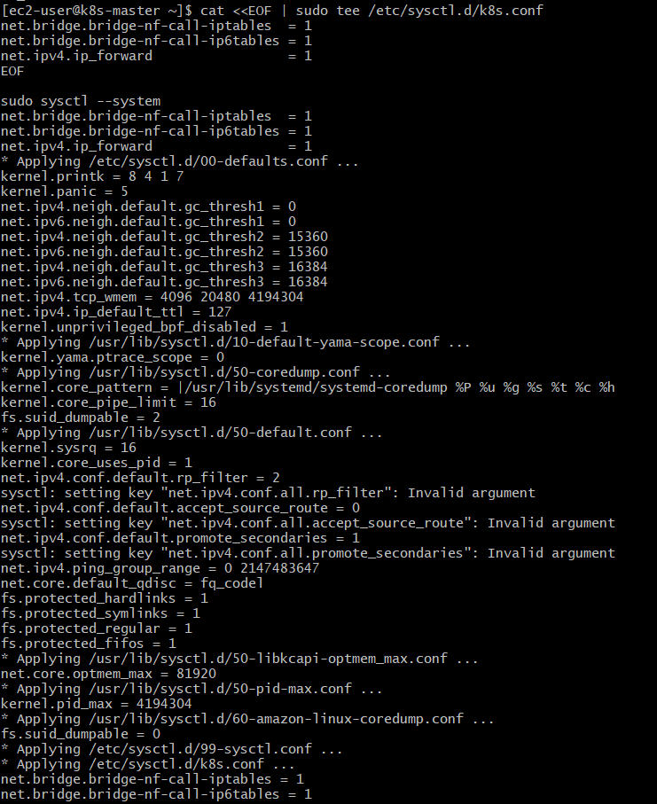
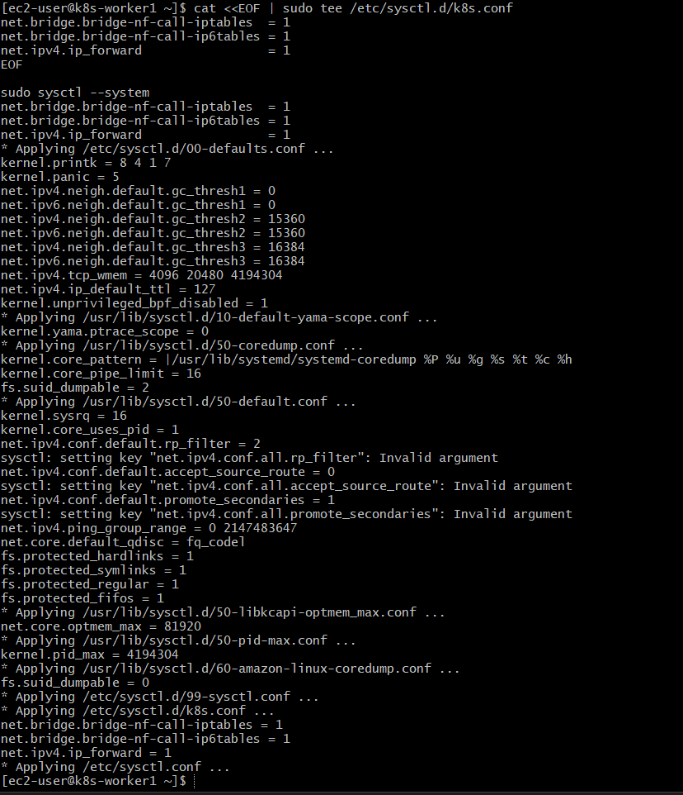
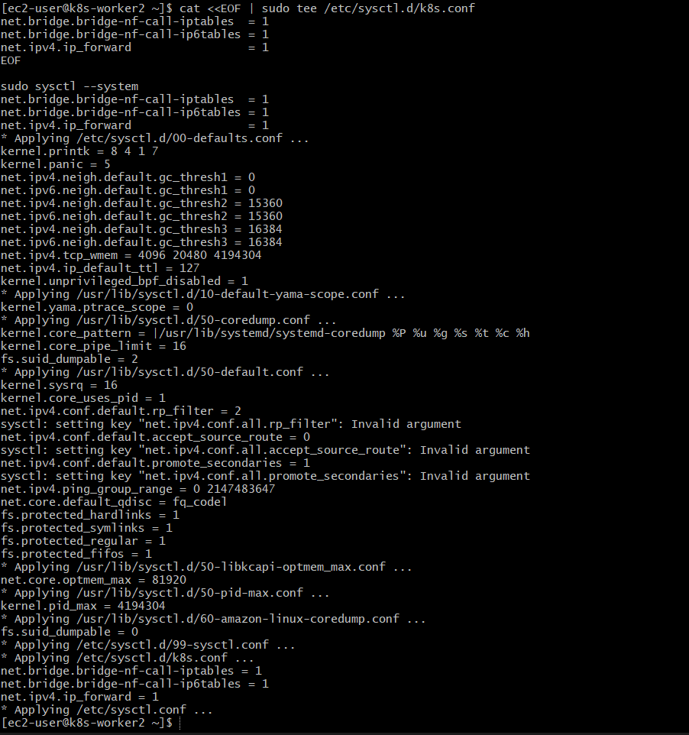

STEP 6: Install Container Runtime (containerd) (ALL NODES)
Run on Master + Worker1 + Worker2
6.1 Update System
sudo apt update -y

6.2 Install containerd
sudo apt install -y containerd

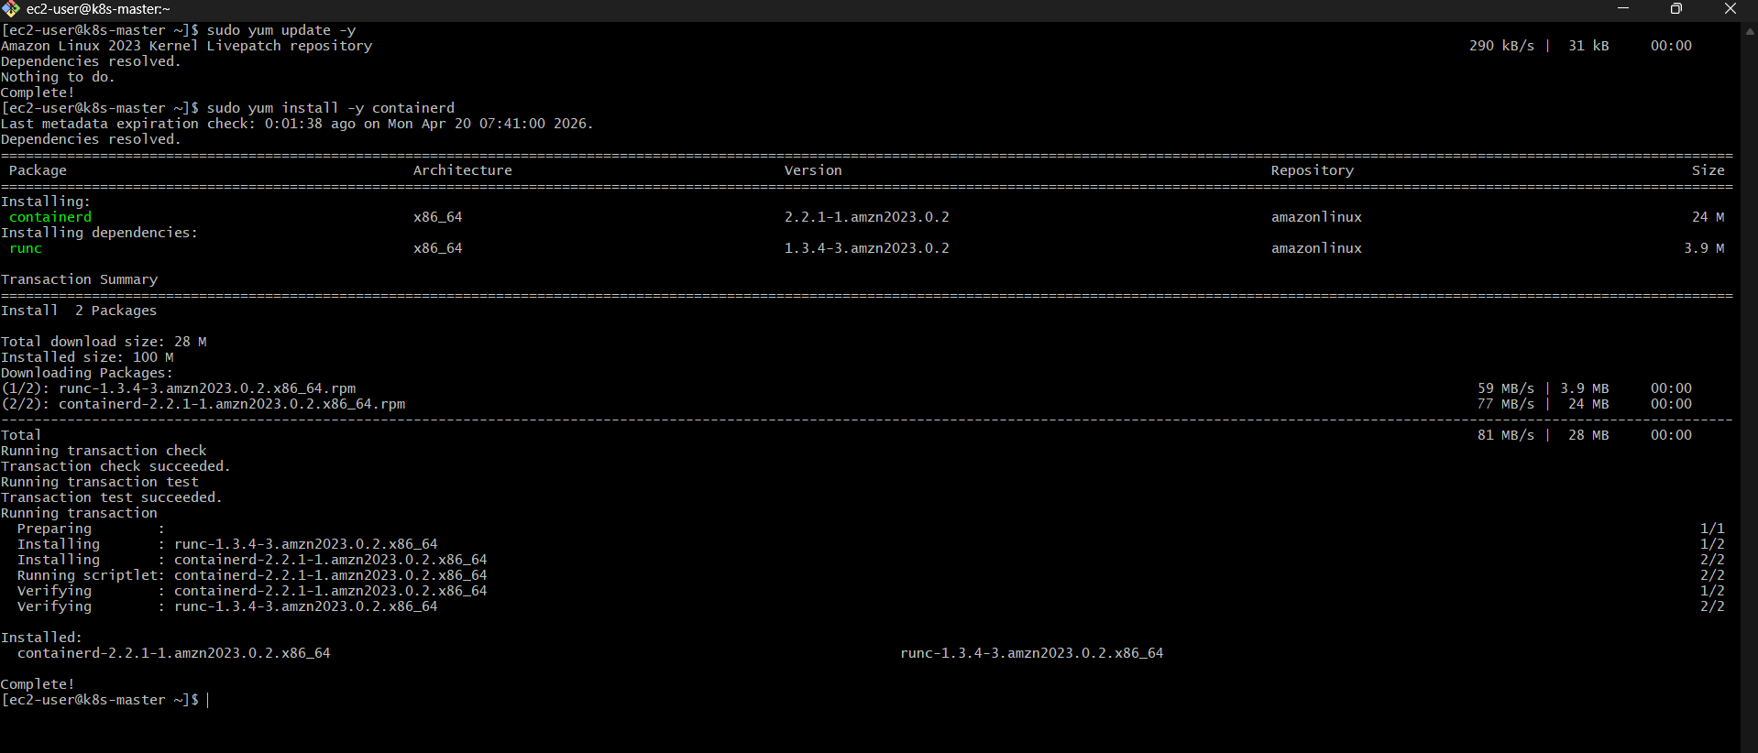
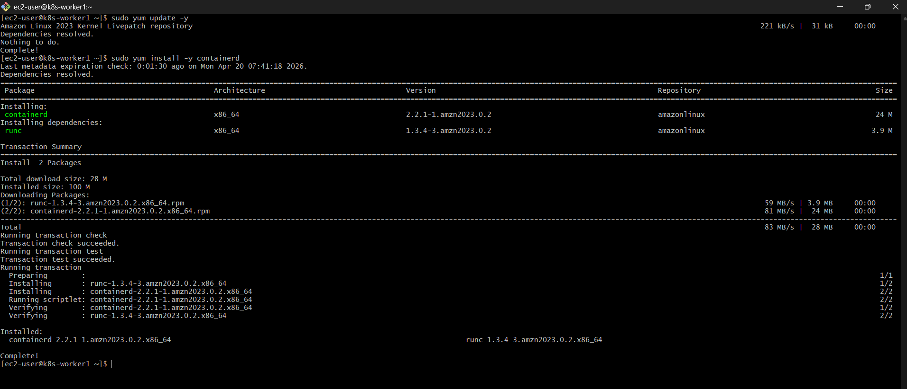
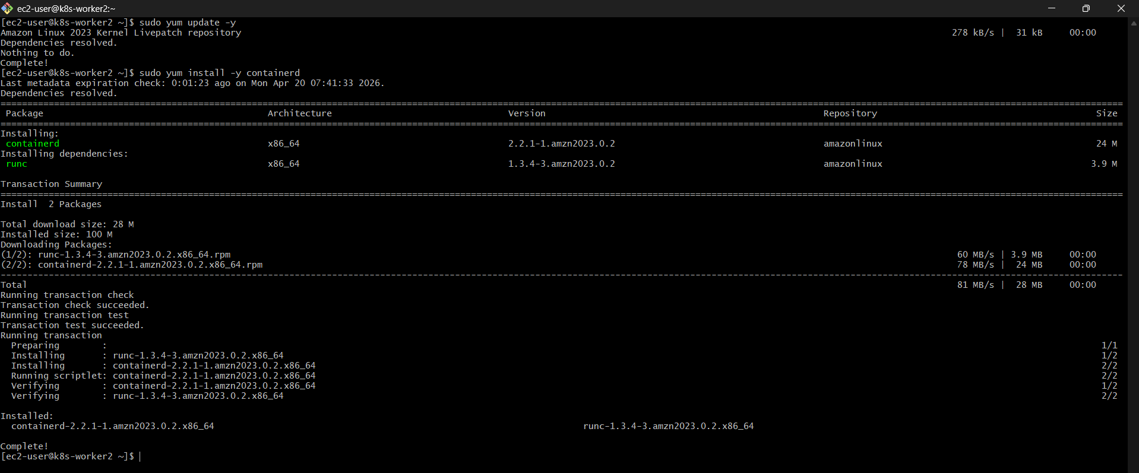

6.3 Start & Enable containerd
sudo systemctl start containerd
sudo systemctl enable containerd

6.4 Verify Installation
containerd –version
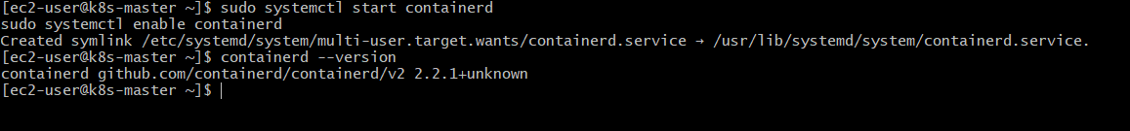
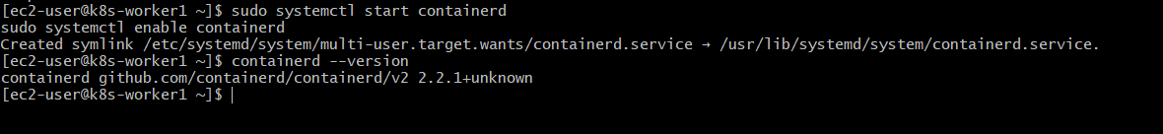
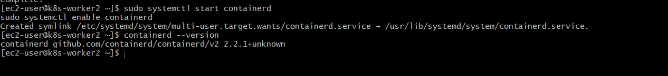

6.5 Generate Default Config
sudo mkdir -p /etc/containerd
containerd config default | sudo tee /etc/containerd/config.toml

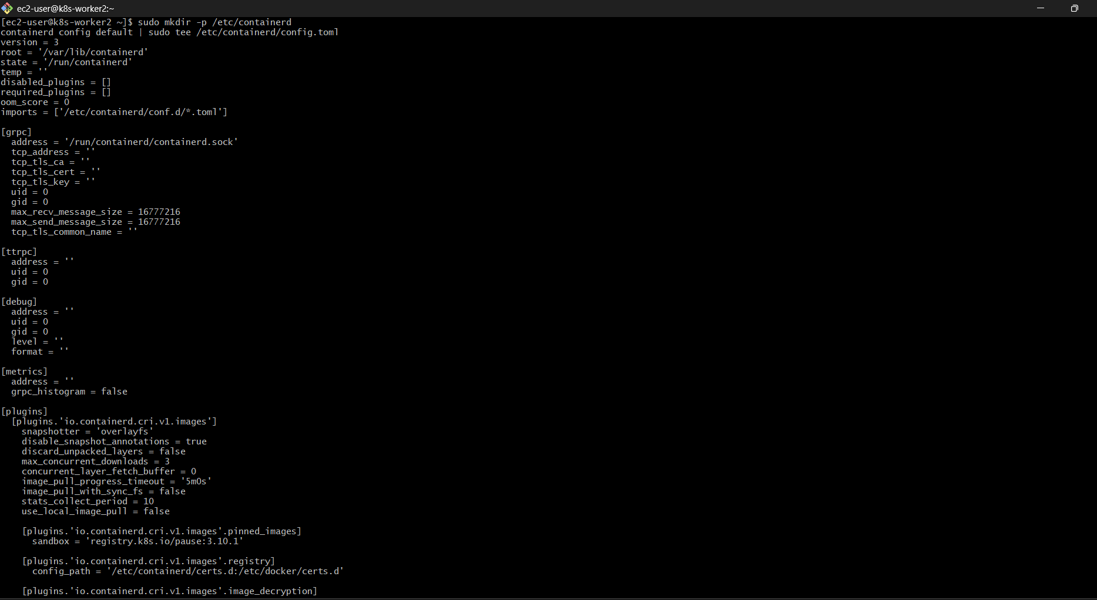
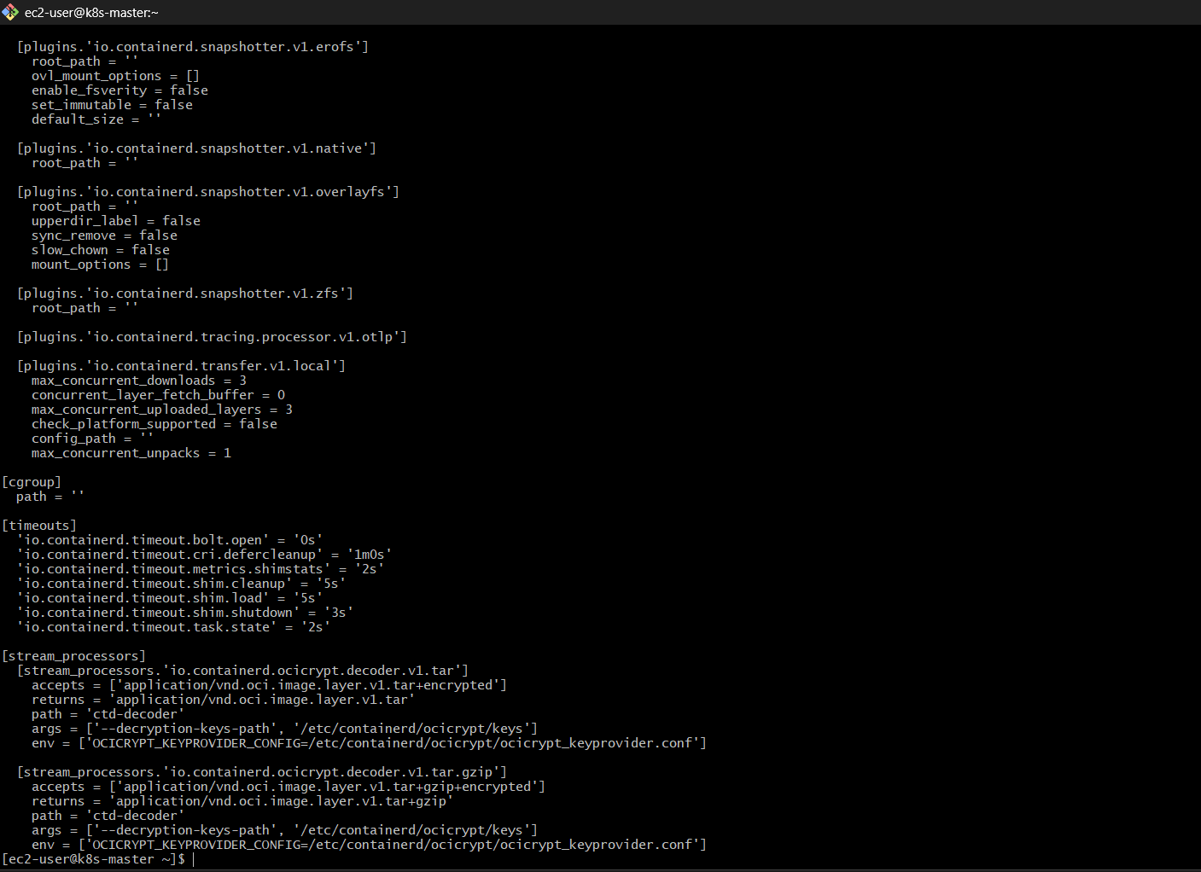

6.6 IMPORTANT FIX (Don’t Skip)
sudo nano /etc/containerd/config.toml
Find:
SystemdCgroup = false
Change to:
SystemdCgroup = true
👉 This is mandatory for Kubernetes, otherwise nodes go NotReady.
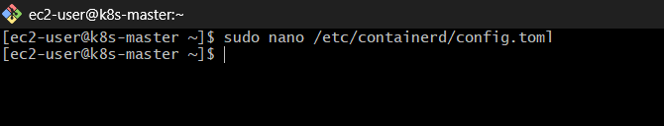
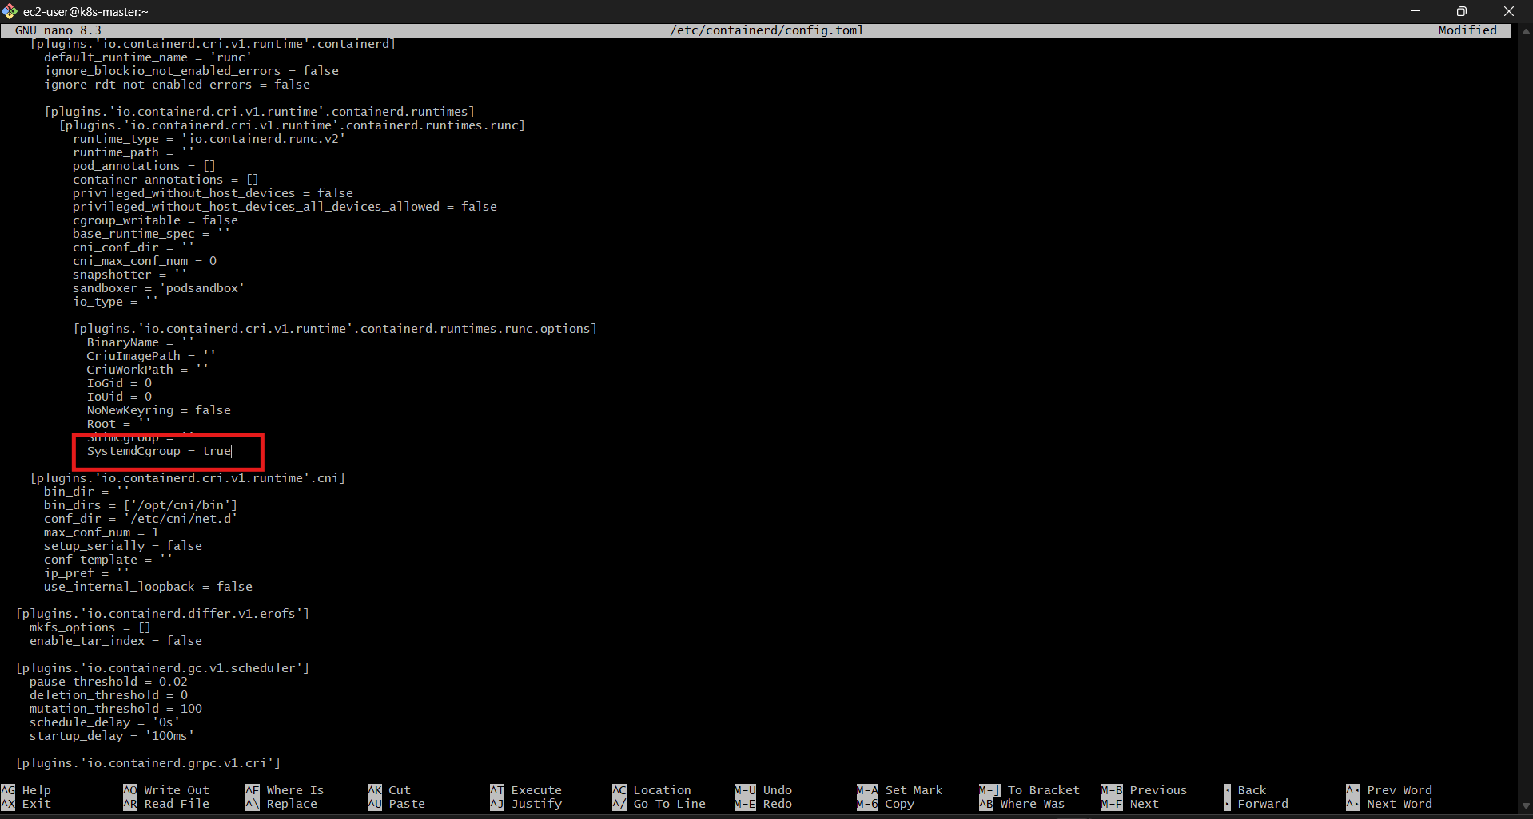

6.7 Restart containerd
sudo systemctl restart containerd

6.8 Enable Required Kernel Modules
sudo modprobe overlay
sudo modprobe br_netfilter
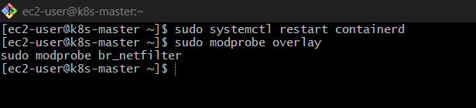
Persist them:
cat <<EOF | sudo tee /etc/modules-load.d/containerd.conf
overlay
br_netfilter
EOF

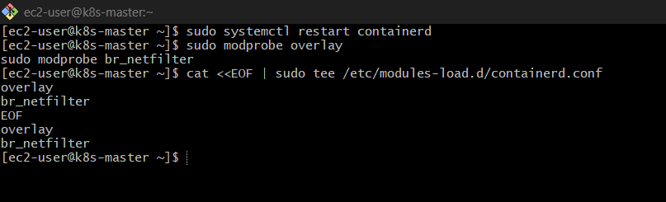

6.9 Configure Sysctl (Networking)
cat <<EOF | sudo tee /etc/sysctl.d/99-kubernetes-cri.conf
net.bridge.bridge-nf-call-iptables = 1
net.bridge.bridge-nf-call-ip6tables = 1
net.ipv4.ip_forward = 1
EOF

Apply:
sudo sysctl –system
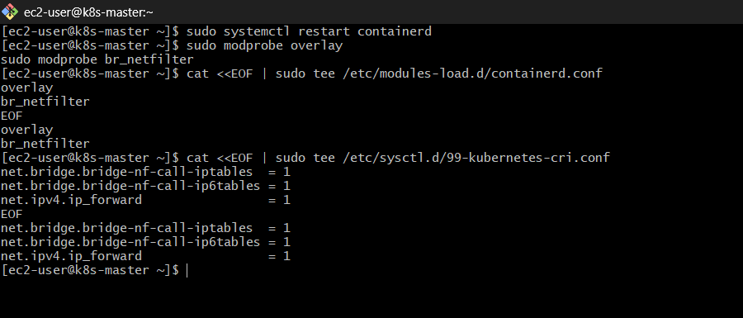
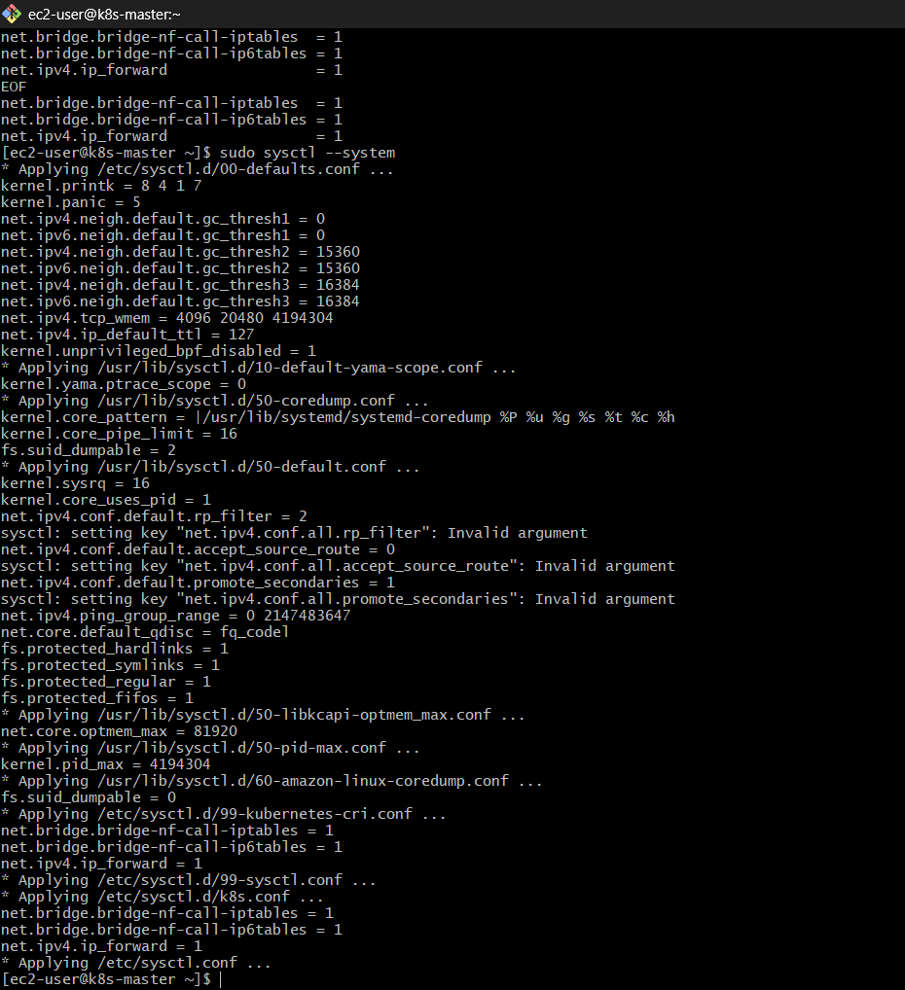

6.10 Verify containerd Service
sudo systemctl status containerd
👉 Expect:
active (running)
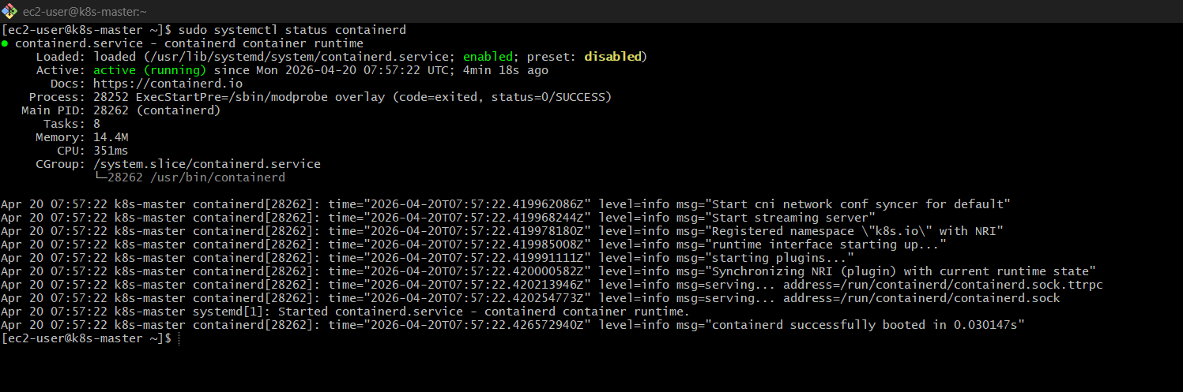

✅ Final Check
sudo systemctl is-active containerd
Output:
active
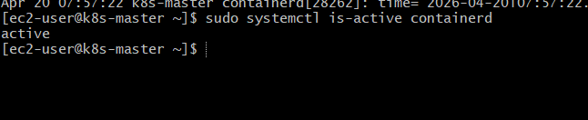

STEP 7: Install Kubernetes Components
👉 Run on Master + Worker1 + Worker2

7.1 Update System
sudo apt update -y
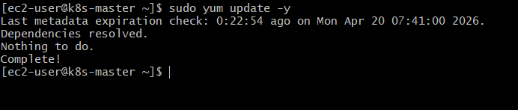

7.2 Add Kubernetes Repo
cat <<EOF | sudo tee /etc/yum.repos.d/kubernetes.repo
[kubernetes]
name=Kubernetes
baseurl=https://pkgs.k8s.io/core:/stable:/v1.29/rpm/
enabled=1
gpgcheck=1
gpgkey=https://pkgs.k8s.io/core:/stable:/v1.29/rpm/repodata/repomd.xml.key
EOF

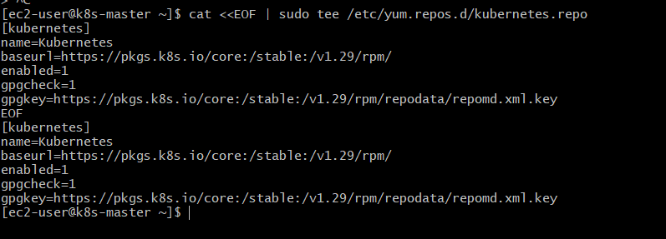

7.3 Install kubeadm, kubelet, kubectl
sudo apt install -y kubelet kubeadm kubectl
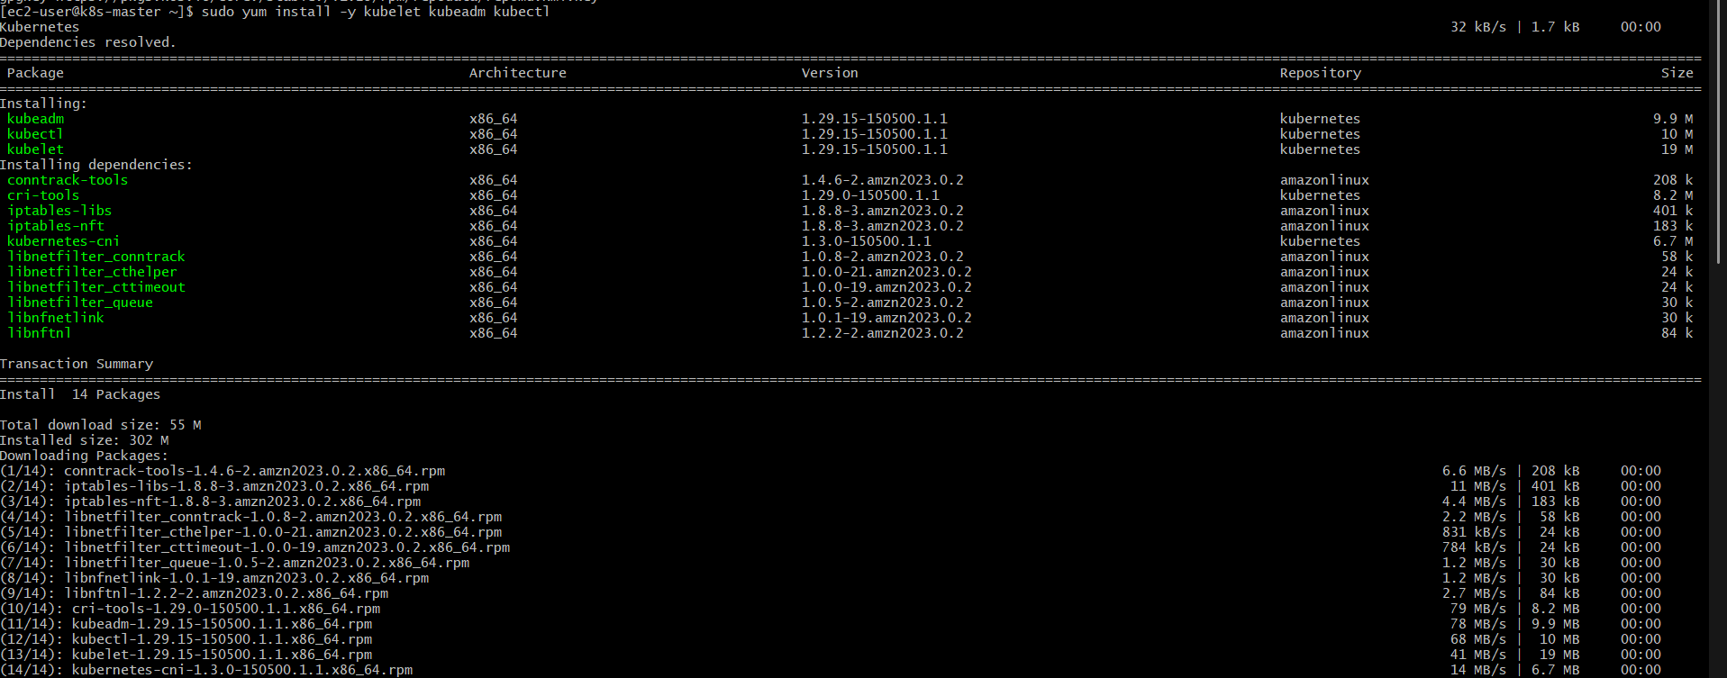
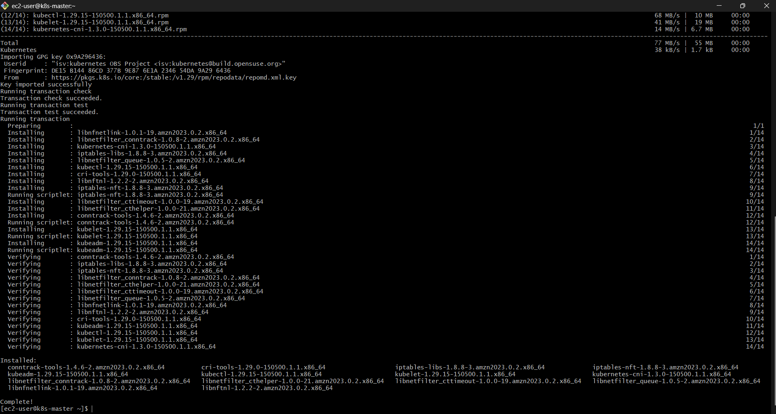

7.4 Enable kubelet
sudo systemctl enable kubelet
sudo systemctl start kubelet
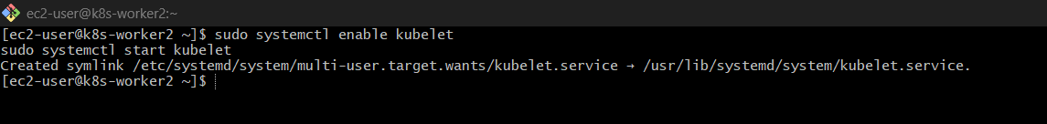

7.5 Disable SELinux (IMPORTANT)
sudo setenforce 0
sudo sed -i 's/^SELINUX=enforcing/SELINUX=permissive/' /etc/selinux/config
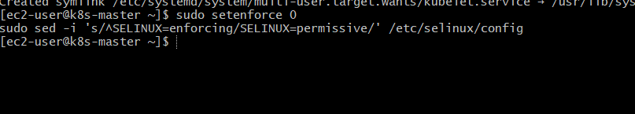

7.6 Disable Swap
sudo swapoff -a
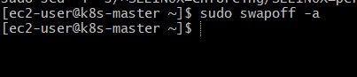

STEP 8: Initialize Master Node
👉 Run ONLY on MASTER
sudo kubeadm init --pod-network-cidr=192.168.0.0/16

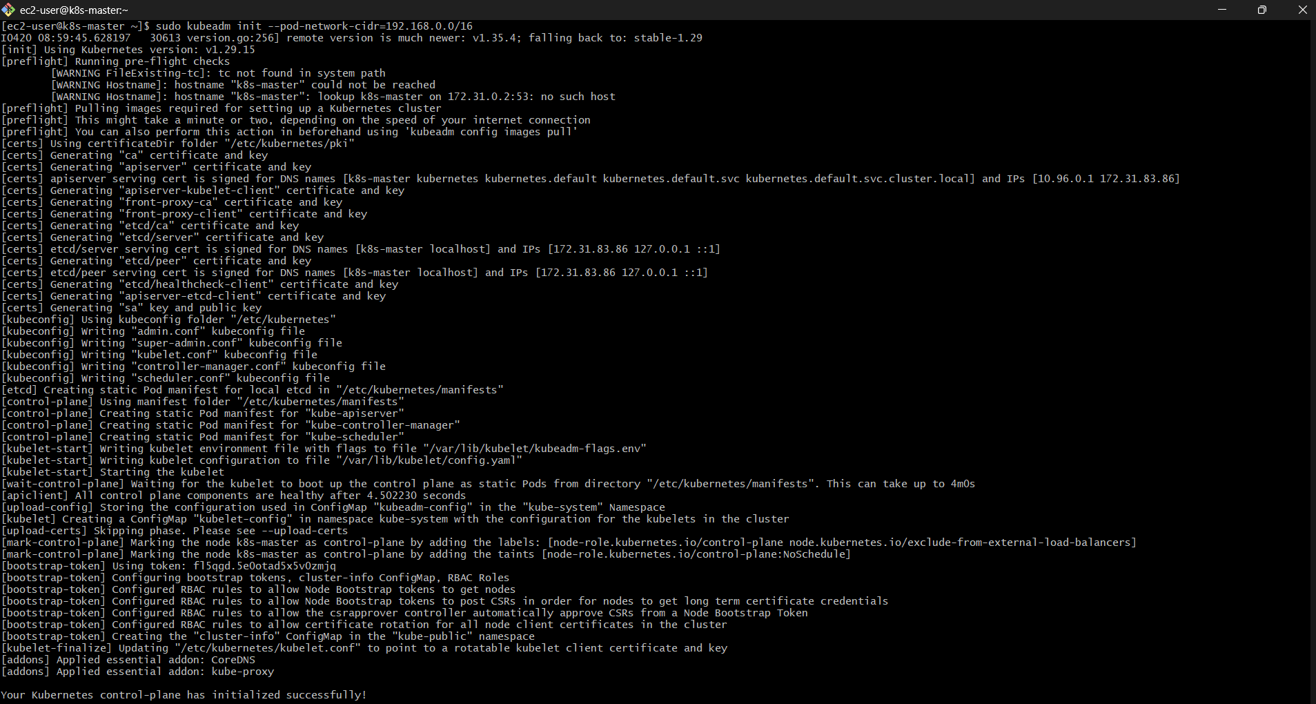
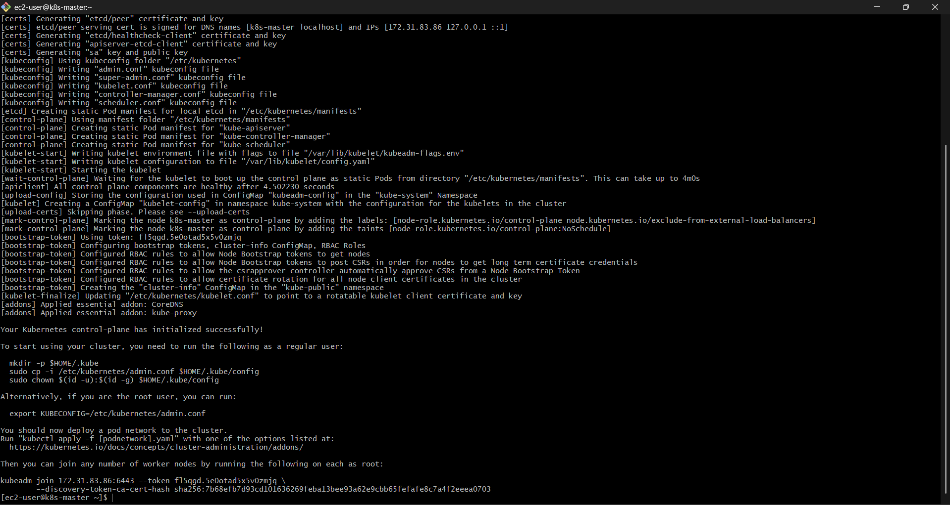

Save Join Command
You’ll get something like:
kubeadm join <MASTER-IP>:6443 --token XXXXX \
--discovery-token-ca-cert-hash sha256:XXXXX

👉 Save this carefully (for workers)

kubeadm join 172.31.83.86:6443 --token fl5qgd.5e0otad5x5v0zmjq \
--discovery-token-ca-cert-hash sha256:7b68efb7d93cd101636269feba13bee93a62e9cbb65fefafe8c7a4f2eeea0703

STEP 9: Configure kubectl (MASTER)
mkdir -p $HOME/.kube
sudo cp -i /etc/kubernetes/admin.conf $HOME/.kube/config
sudo chown $(id -u):$(id -g) $HOME/.kube/config
Test:
kubectl get nodes
👉 Status = NotReady (normal now)
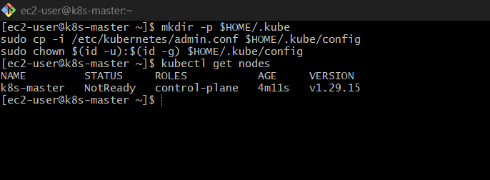

STEP 10: Install Network Plugin (Calico)
👉 Run on MASTER

kubectl apply -f https://docs.projectcalico.org/manifests/calico.yaml
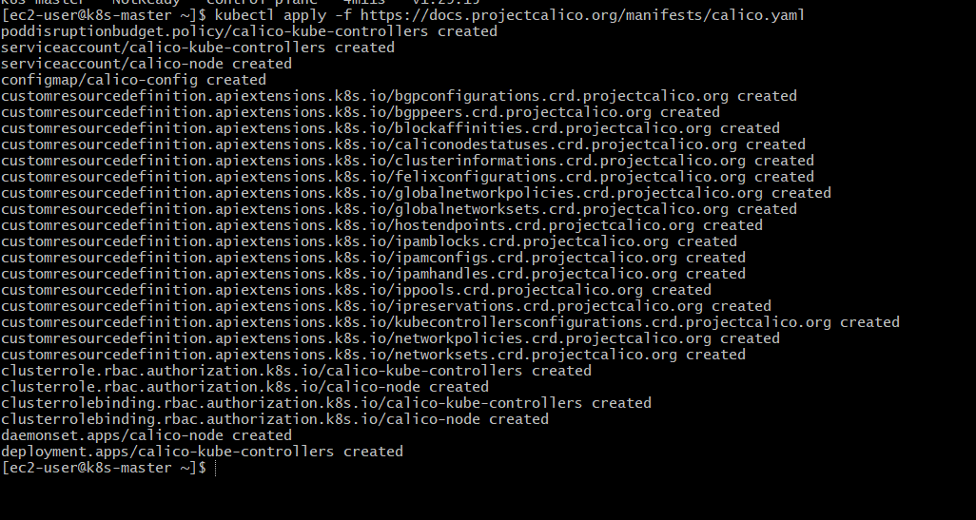

STEP 11: Join Worker Nodes
👉 Run on Worker1 & Worker2
sudo kubeadm join <MASTER-IP>:6443 --token XXXXX \
--discovery-token-ca-cert-hash sha256:XXXXX
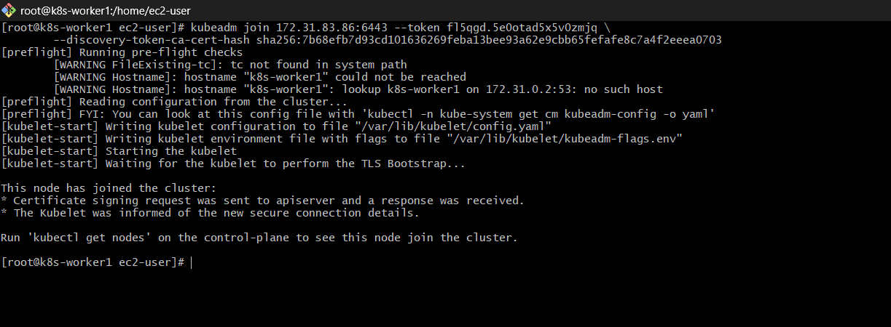
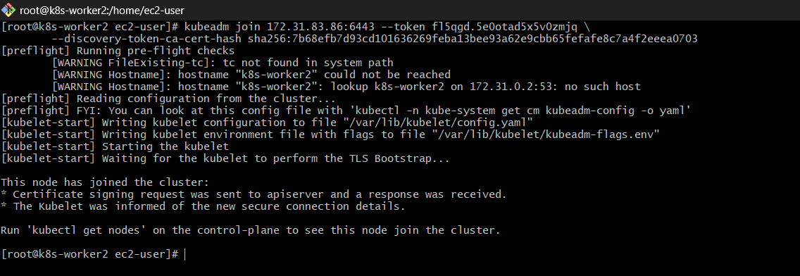
STEP 12: Verify Cluster
👉 Run on MASTER
kubectl get nodes

Expected:
k8s-master Ready
k8s-worker1 Ready
k8s-worker2 Ready
If NotReady, wait 1–2 mins (Calico initializing)

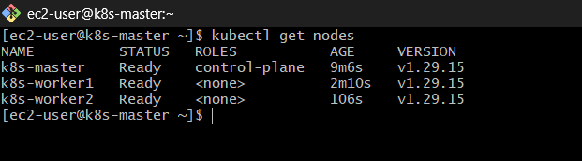

STEP 13: Test Deployment
👉 Run on MASTER
Create Deployment
kubectl create deployment nginx --image=nginx
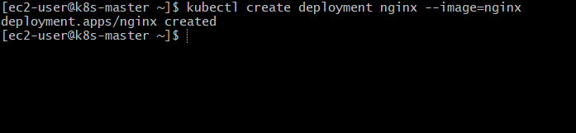

Expose Service
kubectl expose deployment nginx --type=NodePort --port=80

Check Service
kubectl get svc

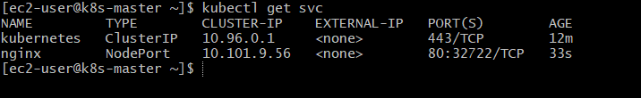
👉 You’ll see something like:
nginx NodePort 80:30007/TCP

Access Application
👉 Open in browser:
http://<Worker-IP>:<NodePort>

Example:
http://192.168.1.10:30007
http://44.204.194.234:32722/

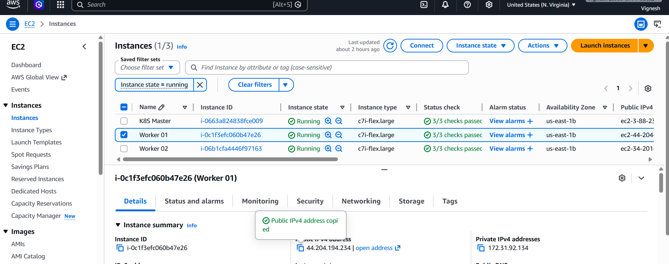
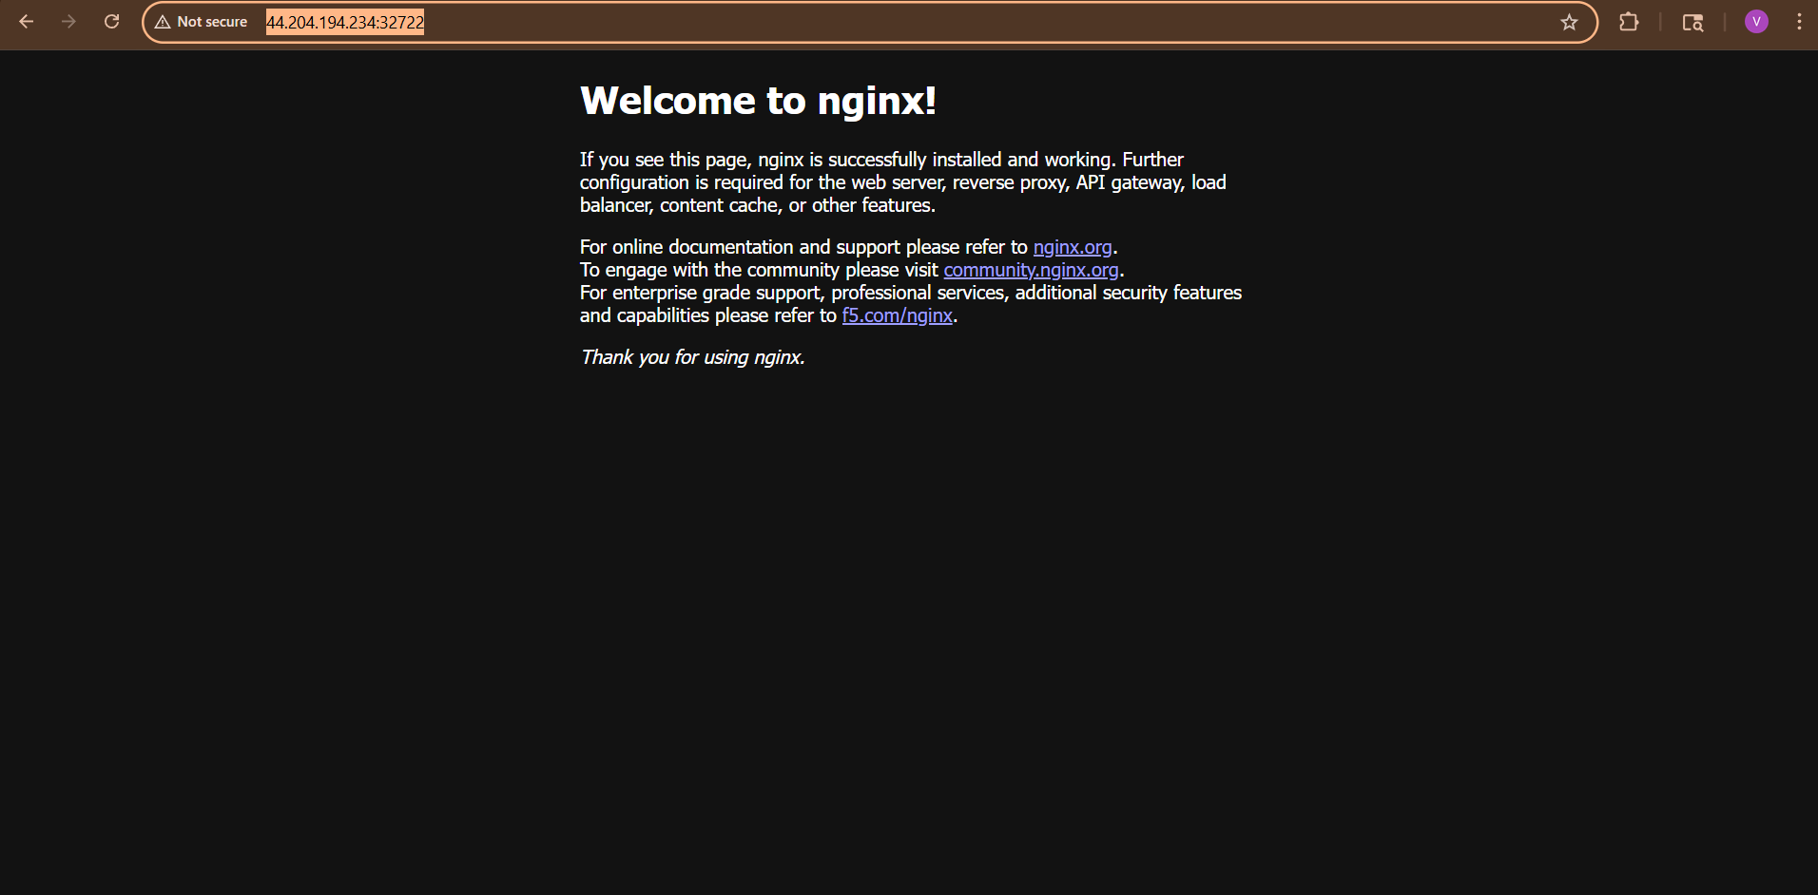

http://34.201.60.24:32722/

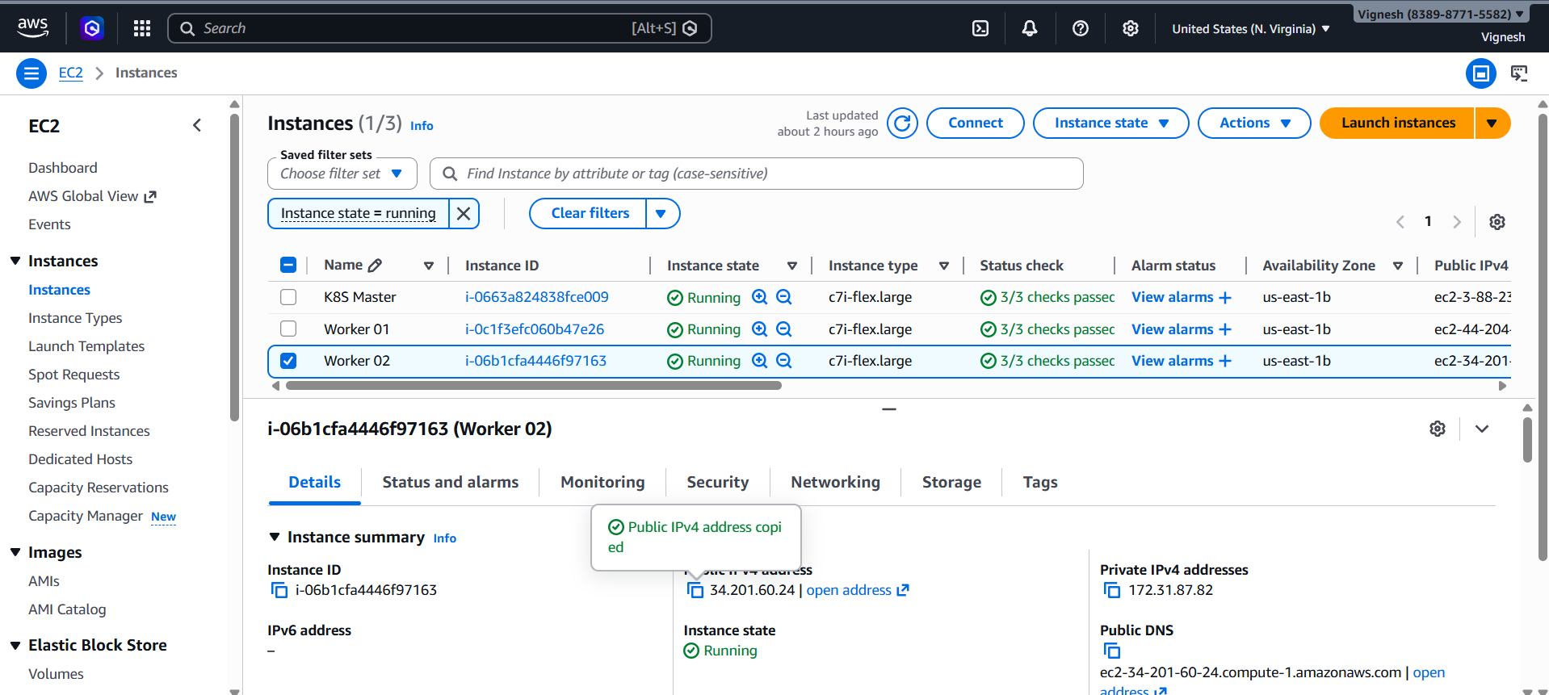
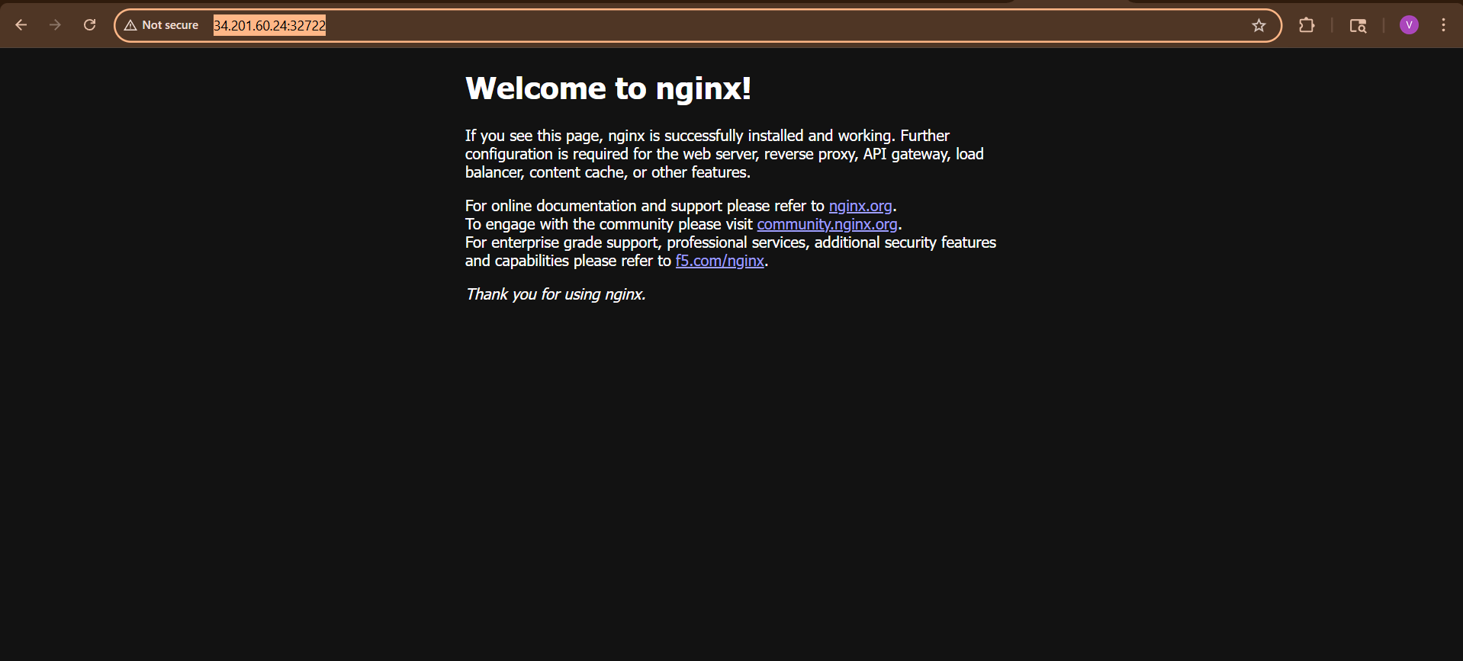

IMPORTANT (Amazon EC2 Users)
If it does NOT open, 99% chance it’s Security Group issue
Fix Security Group
Go to AWS → EC2 → Security Groups → Inbound Rules
Add:
- Type: Custom TCP
- Port: 32722
- Source: 0.0.0.0/0
👉 Or safer:
- Source: Your IP

Common Issues (Amazon Linux)
❌ kubeadm init fails
👉 Run:
sudo systemctl restart containerd

❌ Nodes Not Ready
👉 Check:
kubectl get pods -n kube-system

❌ Token expired
kubeadm token create --print-join-command

Done
You now have:
- ✅ Amazon Linux Kubernetes Cluster
- ✅ 1 Master + 2 Workers
- ✅ Working NGINX deployment

Final Status
You now have:
- ✅ Working Kubernetes cluster
- ✅ Deployment running
- ✅ Service exposed (NodePort)
- ✅ Ready to access via browser

3) Run one nginx pod.

Step 1: Make sure cluster is ready

You need a running Kubernetes cluster (Minikube / K8s setup).

👉 If using Minikube:
minikube start

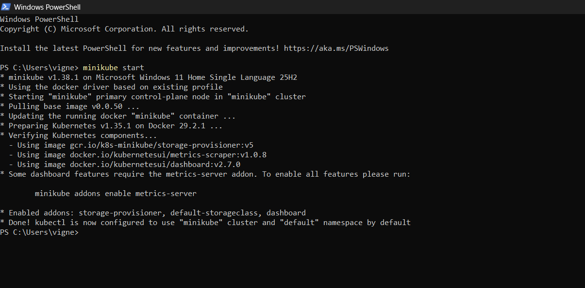
👉 Check cluster:

kubectl get nodes

You should see STATUS = Ready

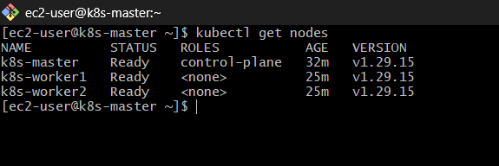

Step 2: Create NGINX Pod (Direct Command)

Run this one-liner:

kubectl run nginx-pod --image=nginx --restart=Never

This creates:

Pod name: nginx-pod

Image: nginx

Restart policy: Never (pure pod, not deployment)

Step 3: Verify Pod

kubectl get pods

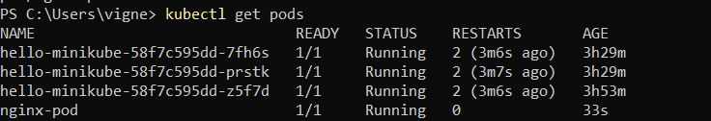
Expected output:
nginx-pod 1/1 Running

Step 4: Describe Pod

kubectl describe pod nginx-pod

Shows:

IP address

Node assigned

Events

Container details

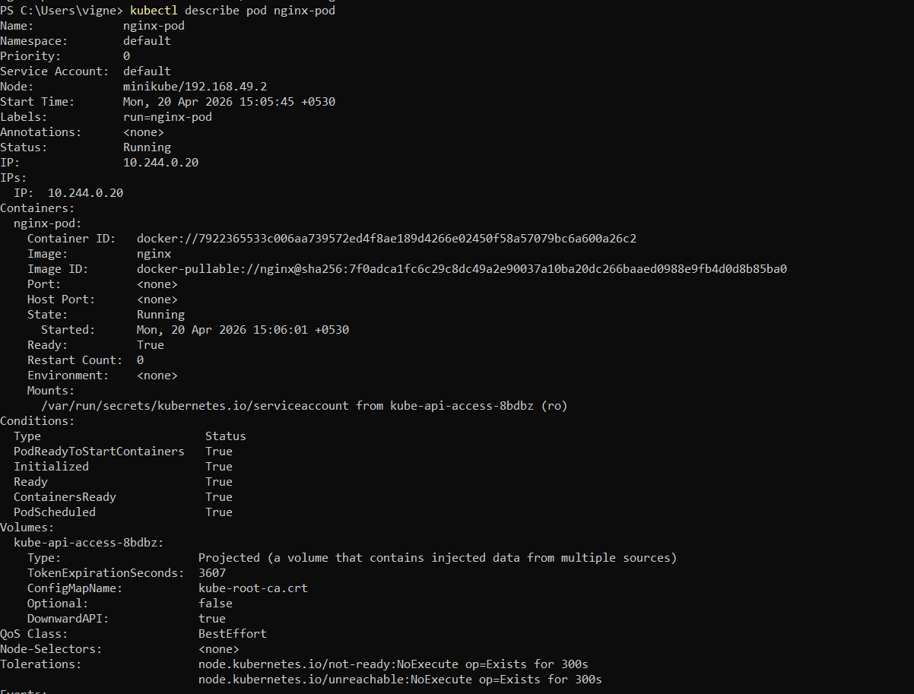
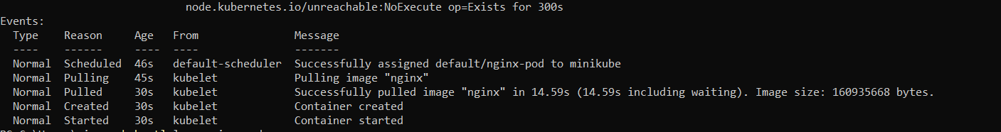

Step 5: Check Logs

kubectl logs nginx-pod

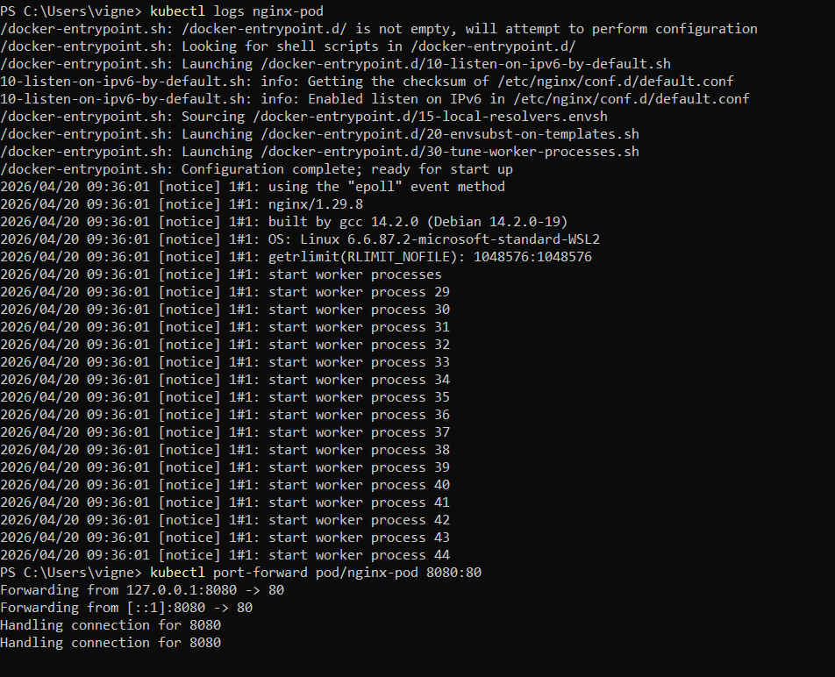

Step 6: Access NGINX

Option 1: Port Forward (Easiest)

kubectl port-forward pod/nginx-pod 8080:80

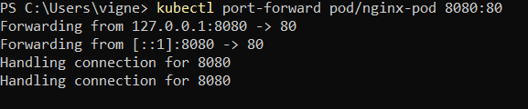

Now open browser:

http://localhost:8080

You’ll see NGINX welcome page

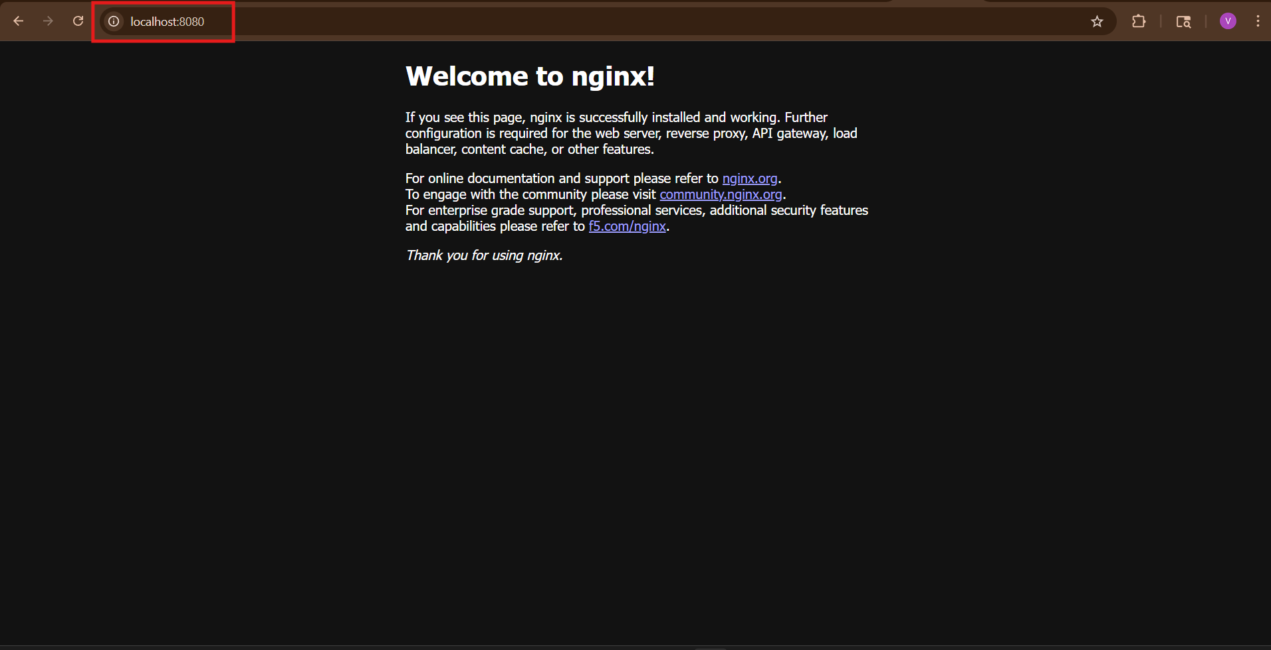

Option 2: Get Pod IP (Internal)

kubectl get pods -o wide

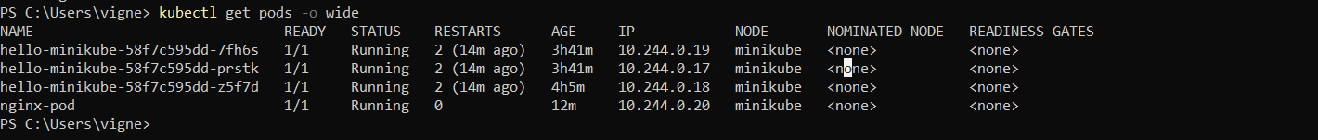

Then:

http://<POD-IP>

Works only inside cluster network

Step 7: Delete Pod

kubectl delete pod nginx-pod

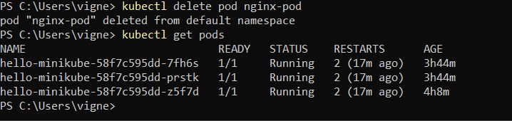

Alternative (YAML Method )

Create file:

vi nginx-pod.yaml

Paste:

apiVersion: v1
kind: Pod
metadata:
name: nginx-pod
spec:
containers:
- name: nginx-container
image: nginx
ports:
- containerPort: 80

Apply:

kubectl apply -f nginx-pod.yaml

Important Notes

Pod = smallest unit in Kubernetes

kubectl run → quick creation

YAML → production method

NGINX runs on port 80

4) Master and slave components on k8s.

Kubernetes Architecture (Master & Worker Nodes)
In Kubernetes, the cluster is divided into:
- Master Node (Control Plane) → Controls the cluster
- Worker Nodes (Slave Nodes) → Run applications (containers)

Master Node (Control Plane Components)
The Master Node manages the entire Kubernetes cluster.
1. API Server
- Full name: kube-apiserver
- Entry point of Kubernetes
- All commands (kubectl) go through this
- Handles REST API requests
👉 Example: When you run kubectl get pods, API server processes it

2. etcd
- Distributed key-value database
- Stores cluster data (pods, nodes, configs)
- Very important for cluster state
👉 Think of it as: Brain memory of Kubernetes

3. Scheduler
- Full name: kube-scheduler
- Decides which node will run a pod
- Based on:
  - CPU / Memory
  - Resource availability
  - Constraints

4. Controller Manager
- Full name: kube-controller-manager
- Runs controllers like:
  - Node Controller
  - Replication Controller
  - Endpoint Controller
👉 Ensures desired state = actual state
Example:
- If a pod crashes → controller creates a new one

5. Cloud Controller Manager (Optional)
- Used in cloud environments (AWS, Azure)
- Manages:
  - Load balancers
  - Storage
  - Networking

Worker Node (Slave Node Components)
Worker nodes actually run your applications.

1. Kubelet
- Agent running on each node
- Communicates with Master
- Ensures containers are running properly

2. Kube Proxy
- Handles networking
- Maintains network rules
- Enables communication between pods/services
👉 Example:
- Service → Pod routing happens via kube-proxy

3. Container Runtime
- Runs containers
- Examples:
  - Docker
  - containerd
  - CRI-O
👉 Responsible for:
- Pulling images
- Running containers

4. Pods
- Smallest unit in Kubernetes
- Contains one or more containers

🔁 How Master & Worker Work Together

- User sends command using kubectl
- API Server receives request
- Scheduler selects a worker node
- Controller ensures pod is created
- Kubelet runs container on worker node
- Kube-proxy manages networking

Simple Diagram (Concept)

MASTER NODE (Control Plane)
---------------------------
API Server
Scheduler
Controller Manager
etcd
|
↓
WORKER NODE (Slave)
---------------------
Kubelet
Kube-proxy
Container Runtime
Pods (Applications)

Key Points

- Master node = Control Plane
- Worker node = Executes workload
- etcd = Stores cluster state
- Scheduler = Assigns pods
- Kubelet = Node agent
- Kube-proxy = Networking

